


Environmental Performance Assessment Scheme (EPAS) Consultation
October 2025
We asked, you said, we did

Contents

Contents 2
Executive summary 3
We asked: 3
Introduction 5
Consultation responses at a glance 9
Principles 9
Proposed scheme 9
Other considerations 9
Key themes in responses 9
Performance rating 9
Priority sites 9
Timescales 9
Harm caused – environmental events 11
Complex sites 11
Appeals 13
Major non-compliance criteria 13
Voluntary actions beyond compliance 15
Business impacts 15
Issues raised for further guidance or explanations 16
Next steps for EPAS 16

Executive summary

We asked:
We consulted on our proposed Environmental Performance Assessment Scheme (EPAS) from 31 March to 30 June 2025. This was supported by a programme of engagement and communications. We held three information sessions that attracted 172 attendees. Social content generated around 30,000 views and our newsletter link had 15,000 views/opens, which translated into approximately 3,500 visits to the online EPAS consultation hub.
In our consultation, we explained that EPAS will support our approach to regulation and provide us with a common standard to rate an operator’s environmental performance and secure improvements in compliance. Our consultation set out the proposals for who EPAS will apply to, how environmental performance is assessed and the timescales for implementation. We asked a total of 22 questions to explore how well people understood our proposals, whether they supported the key principles of the scheme, and what, if anything, could be improved. We also asked what impact they thought the scheme would have on Scotland’s environment, and specifically asked businesses what impact they thought the scheme would have on their operations.
You said:
We received a total of 73 responses. 46 were from organisations, businesses or their representatives, for example, industry trade bodies which represent, in some cases, thousands of members. 27 responses were from individuals or community groups. 87% of respondents thought that they understood the proposals quite well or very well. There was strong support for the principles of the scheme: real time relevancy, inclusion of time to resolve compliance issues and a priority sites list.
There was support for the specifics of the scheme and the appeals process. Some common concerns were expressed over specific proposals in multiple questions, including where significant time and investment would be required to resolve compliance issues.

We did:
The consultation provided us with valuable insights into what people thought about EPAS, and we have made four key changes to improve our proposals:
- Renaming the middle EPAS rating to ‘Improvement required’ (previously proposed to be called ‘Below expectations’).
- Providing flexibility within the scheme for SEPA to allow operators more time (known as an “extension”) to resolve non-compliance where, in our opinion, there are legitimate reasons.
- Providing flexibility within the scheme so that a serious environmental incident (commonly referred to as a category 1 or 2 environmental event) will not automatically result in an ‘Unacceptable’ performance rating, where, in SEPA’s opinion, there are exceptional, unforeseen circumstances not due to the actions of the operator.
- Clarifying that Stage 3 of the appeals process (the formal appeal stage) will be carried out by a different “portfolio” (strategic business area) within SEPA (the Governance, Performance and Engagement portfolio) and therefore be independent within SEPA. Frontline resolution and Management review (stages 1 and 2) will be undertaken within the Regulation, Business and Environment portfolio.

Some changes were also made to criteria we use to define what we describe as major non-compliant to account for specific feedback received from relevant stakeholders. The revised major non-compliance criteria will be posted on our website by 01 December 2025. We will start to apply major non-compliance criteria from 01 January 2026.
This document summarises the feedback gathered during the consultation and describes how we will respond.

Introduction
Scotland’s environmental laws help to protect and enhance our environment so that future generations can thrive. However, they are only effective when there is strong compliance with them. Ensuring this is the case is an important part of our job. We consulted on a new Environmental Performance Assessment Scheme (EPAS) from 31 March to 30 June 2025. EPAS is designed to drive action to resolve compliance issues that could cause harm to communities and nature.
EPAS will replace our 2009-2019 Compliance Assessment Scheme (CAS) and communicate the environmental performance of operators (relevant authorised person, business or organisation) with respect to:
- Compliance: how serious any non-compliance was.
- Time: how long it took to correct any non-compliance.
- Environmental harm: the level of any environmental harm caused.
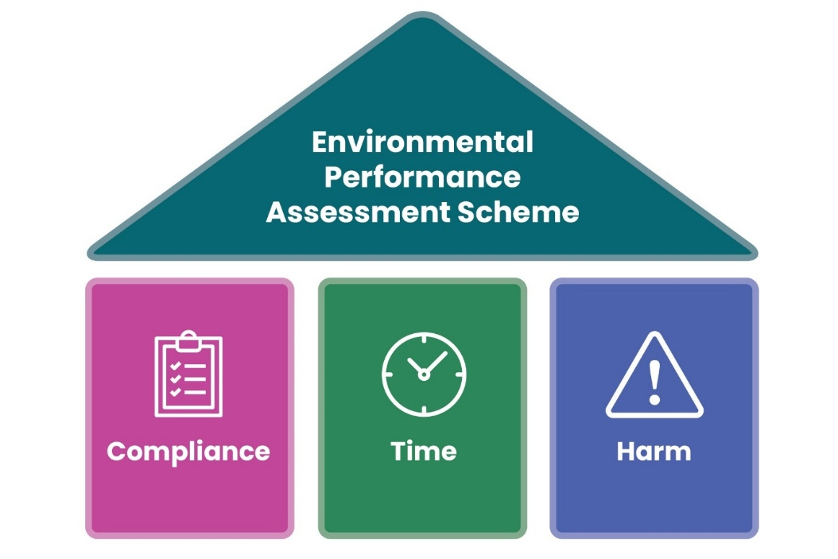
EPAS takes a different approach to CAS and provides a different lens through which environmental performance can be understood.

Figure 1: The three parts of EPAS: compliance category, time taken to resolve non-compliance and environmental harm caused.
EPAS will enable operators regulated by SEPA who comply with their environmental requirements to demonstrate this, while those falling short will be held publicly accountable faster than ever before. Our regulatory priority is operators who have ‘Unacceptable’ performance with no credible plan to resolve compliance issues; these will be published on a priority sites list.
Who provided responses
In total, we received 73 responses from a range of businesses, representative organisations, community groups, public sector agencies and members of the public, see table 1.
Table 1: Respondents to the consultation by organisation type.
Organisation type | Number of respondents | Percentage
Large business or corporation | 17 | 23%
Community group | 14 | 19%
Public sector or government agency | 12 | 16%
Member of the public | 11 | 15%
Industry trade body | 7 | 10%
Small or medium-sized business | 6 | 8%
Representative organisation | 4 | 5%
Non-governmental organisation | 1 | 1%
Consultancy | 1 | 1%
Total | 73

The sector representation from the 23 regulated businesses (17 large businesses or corporations and six small to medium sized businesses) that responded can be viewed in table 2.
Table 2: Sector representation of the regulated businesses that responded to the consultation. Some respondents selected more than one activity. These figures exclude the industry trade bodies and representative organisations listed in table 3.
Sector / Activity type | Number of respondents | Percentage
Waste or materials recovery | 11 | 27%
Energy generation | 7 | 17%
Manufacturing or processing | 7 | 17%
Farming aquaculture | 5 | 12%
Construction | 3 | 7%
Farming other | 2 | 5%
Healthcare and clinical | 2 | 5%
Other | 2 | 5%
Water supply or waste water | 2 | 5%
Total | 41

We also received responses from seven industry trade bodies and six representative organisations, see table 3. Therefore, caution should be applied when interpreting the percentages for each question as each organisation was counted as one respondent.

Table 3: Industry trade bodies and representative organisations that responded to the consultation.
Organisation Name | Number of organisations or professionals represented
The Law Society of Scotland | Approximately 13,000 Scottish solicitors
National Farmers Union (NFU) Scotland | Approximately 9,000
The Chartered Institution of Wastes Management (CIWM) Scotland | Approximately 8,000
Chemical Industries Association | Approximately 200
The Scotch Whisky Association | 90
Resource Management Association Scotland | 77
Fisheries Management Scotland | 67
Salmon Scotland (written response received so not included within figures) | 57
British Trout Association | Approximately 30
Mineral Products Association Scotland Limited | 20
Scottish Environmental Services Association | Not stated

Consultation responses at a glance

Principles
There was strong support for the core principles of EPAS:
- 90% thought that the inclusion of time to resolve compliance issues was important or very important.
- 78% agreed that real time relevancy was important to enable everyone to take decisions based on an EPAS rating.
- 63% agreed that publishing a priority sites list would drive improvements in performance.
- 58% thought that the overall impact of EPAS for Scotland’s environment would be positive.

Proposed scheme
There was good support for the specifics of EPAS:
- 53% agreed with the proposed performance ratings.
- 55% thought that EPAS was fair.
- Most respondents thought that the timescales proposed were about right (see questions 4, 5, 6, 11 and 12 in Annex 1).
- Most (65%) respondents thought that the impact on their business would be positive (37%) or minimal or neutral (28%).
- 60% agreed that the appeals process was fair.

Other considerations
There was strong support that EPAS should recognise voluntary actions that go beyond compliance. 74% thought that this was important. However, there were extremely diverse views on how this could be delivered, and important concerns were also raised.
The figures for each of the questions we asked are outlined in Annex 1.

Key themes in responses
We asked 22 questions in the EPAS consultation. To understand better the feedback respondents shared we carried out a thematic analysis to understand what the most significant areas of feedback were. These themes are presented below along with our response.

Performance rating
We asked for feedback on the three proposed performance ratings:
- Good
- Below expectations
- Unacceptable

Respondents said: The majority (53%) of respondents agreed with the proposed performance ratings. Sixteen respondents specifically stated that the categories were clear, for example:

“the simple and transparent structure provides clarity to the public and regulated operators”

“the three proposed environmental performance ratings appear to provide operators with a simple way of understanding how they are performing”

“three bands are sufficient”

Of those that disagreed the primary concern raised was around the negative bias of ratings, which was raised by four industry trade bodies, two representative organisations and 21 respondents in total. There was concern that the proposed ratings could create a negative perception of the operators’ performance and use of less emotive language was suggested. Some alternative suggestions were provided including ‘Improvement required’. There were also some respondents that believed there should be fewer categories or that the ‘Good’ rating should only be achievable where there were no compliance issues. One respondent said “’Below expectations’ and ‘Unacceptable’ sound too similar”. Only six respondents suggested a ‘beyond compliance’ rating in response to question one (how far they agreed with the proposed performance ratings).

We did accept that it may be beneficial to use more neutral language to describe EPAS ratings. The most common alternative suggested was ‘Improvement required’ so we have decided to amend the middle category from ‘Below expectations’ to ‘Improvement required’. There are also several other rating systems that use the language ‘Improvement required’ such as the Scottish Food Hygiene Information Scheme so this should be a term the public are familiar with.

We do not think it is appropriate to introduce an additional positive category between ‘Good’ and ‘Improvement required’. If the ratings representing unresolved compliance issues are perceived too favourably, the incentive to achieve the highest environmental performance rating of ‘Good’ may be lost. We think that provided compliance issues are resolved quickly, a ‘Good’ rating is sufficient to meet the purpose of the scheme including enabling people to take appropriate actions. We want to prioritise our regulatory efforts on operators with ‘Unacceptable’ performance, specifically those who do not have a compliance recovery plan in place.

Ninety percent of respondents thought that time taken to resolve compliance issues is important to recognise in the environmental performance rating. Given this, we also did not think it was appropriate for the highest rating of ‘Good’ to only be achievable with 100% compliance, or to introduce an additional category of ‘Excellent’ to represent 100% compliance. We recognise that obtaining a 100% compliance record can be more difficult depending on the complexity of the site and whether continuous monitoring is required. We want to recognise that being non-compliant with one authorisation condition for very short time periods, resolving this quickly and causing no environmental harm may be considered ‘Good’ environmental performance. Compliance information will still be made available online so for those interested, it will be possible to view compliance history and see which operators have been 100% compliant with their authorisation conditions.

Priority sites
We asked if publishing a priority site list would drive improvements in performance?
Respondents said: 63% agreed with the proposal to have a priority site list. Those that commented said a priority list would hold operators to account. For example, one respondent said:
“Non-compliant operators need to be seen to be held accountable to give confidence to those operators that strive to ensure compliance on their sites that they are taking the right approach.”
Many businesses who provided feedback were concerned about what information would be published about priority sites and asked for more guidance on what a compliance recovery plan should contain.
We did listen to the support expressed for the priority site list and will retain this. We also understand the reputational concerns raised by businesses and commit to providing further information on compliance recovery plans and what information will be made publicly available.

Timescales
We asked for feedback on the time periods proposed for operators to resolve compliance issues before their environmental performance rating is affected. We proposed two set timescales to resolve compliance issues: 30 days and 180 days, see figure 2.
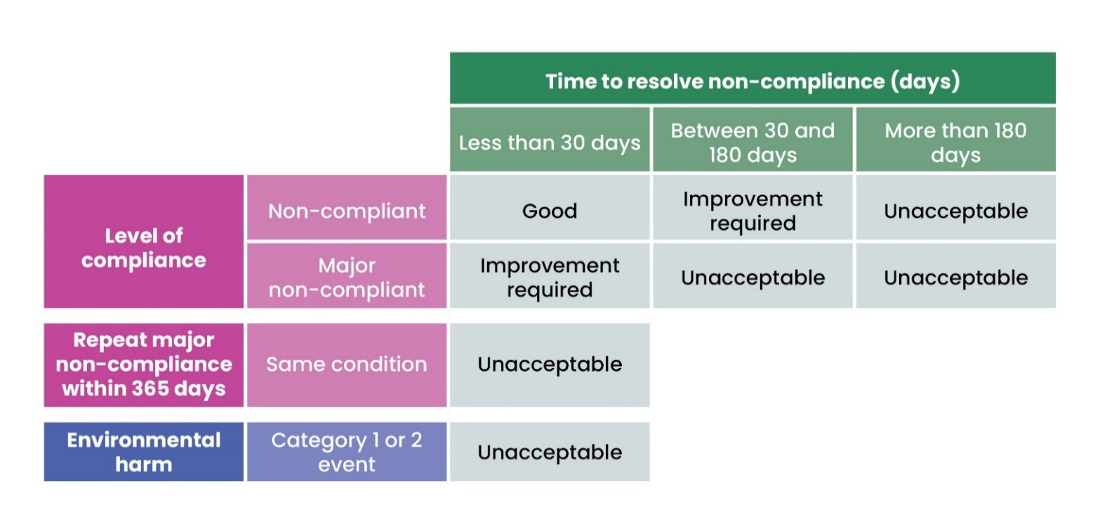
Figure 2: How long an operator takes to resolve a compliance issue affects their environmental performance rating. Extensions for legitimate reasons or exceptions to a category 1 or 2 event automatically resulting in an unacceptable performance rating may be applied.
Respondents said: 90% thought that including time to resolve compliance issues was important.
The largest proportion of respondents thought that the proposed timescales were about right. Where respondents did not agree, views were split on whether timescales should be longer or shorter, see table 4.

Table 4: Response to the questions we asked around the appropriate timescales for EPAS. Percentages given in the ‘about right’ column exclude respondents that answered ‘don’t know’ to these questions.

Question | No time at all | Less time | About right | More time | Don’t know
30 days allowed to resolve non-compliant issues while retaining a 'Good' rating | 10 | 9 | 24 (41%) | 16 | 10
180 days to resolve non-compliant issues before a rating is 'Unacceptable’ | n/a | 18 | 30 (56%) | 6 | 11
30 days to resolve major non-compliant issues before a rating is 'Unacceptable’ | n/a | 17 | 25 (46%) | 12 | 11

A number of respondents thought that while resolving compliance as quickly as possible is important there are legitimate reasons for extensions to the time periods proposed.

We did accept there may be legitimate reasons why, despite best endeavours, an operator may require more time to resolve compliance issues, without it impacting their environmental performance rating. We will publish guidance on what may be considered legitimate reasons.

Harm caused – environmental events
We asked: Should the most serious environmental incidents (category 1 or 2 environmental events) always result in an EPAS rating of ‘Unacceptable’?

Respondents said: 48% of respondents agreed that a category 1 or 2 environmental event should always result in an ‘Unacceptable’ EPAS rating. 33% of respondents agreed, other than in exceptional circumstances. Respondents suggested exceptional circumstances should include force majeure events, unforeseen events that are beyond reasonable control of the operator, external contractors working on site, legacy issues not due to current operator practice and an unavoidable environmental event caused by action to mitigate harm to humans.

We did: accept that there could be some exceptional circumstances where an operator’s performance should not be rated ‘Unacceptable’ despite resulting in environmental harm to the level of a category 1 or 2 event. We will produce guidance on what may be considered exceptional circumstances prior to the publication of EPAS ratings.

Complex sites
We asked: How fair do you think the proposed Environmental Performance Assessment Scheme is?

Respondents said: Most (55%) respondents agreed that EPAS is fair and 22% of respondents disagreed. Of those who disagreed the most common concern was that EPAS could be unfair to complex sites. Eleven regulated businesses and 4 trade bodies expressed views that EPAS could be disproportionately unfair to complex sites. These organisations typically noted the large number of activities and authorisation conditions required for complex sites. This means that an EPAS rating will be published more frequently and there was a view these sites had a higher probability of being rated as ‘below expectations’ (now ‘improvement required’). Some respondents suggested an assessment that considered the percentage of a site’s compliance conditions could be fairer. Some respondents also expressed differing understanding of how multiple non-compliances would be treated and were concerned this could be unfair to sites with more permit conditions.

We did: EPAS was designed to improve the experience of performance assessment for complex sites. Under the previous Compliance Assessment Scheme (CAS), when a business had a compliance issue, there was no time allowed to resolve issues, and any breach of a condition (non-compliance) would always impact a CAS rating. Under EPAS we recognise the large number of compliance requirements that complex sites must meet, and therefore the scheme will allow the 30-day window to resolve issues categorised as non-compliant, whilst still allowing sites to achieve a ‘Good’ rating.

We did consider taking a percentile approach, assessing compliance with a proportion of compliance requirements. However, this approach would disadvantage operators with simple authorisations with few conditions. A percentile approach would also not reflect the severity of any compliance issues, for example, the difference between a non-compliance causing no harm and a major non-compliance causing a category 2 level environmental event. A percentile approach is also difficult to apply to complex sites because not all authorisation conditions are assessed at every inspection. This means that any figure reported would be easy to misinterpret. For example, if 10 out of 100 conditions were assessed and 5 were non-compliant, this could be reported as 50% compliance or 95% compliance. We think that the fairest way for all is to consider compliance at the authorisation scale. This is why we are proposing that any compliance issue will mean that an authorisation is categorised as ‘non-compliant’ and one major non-compliance will mean the authorisation is categorised as ‘major non-compliant’. However, the performance rating is only affected if the compliance issue is not resolved within 30 days or is categorised as ‘major non-compliant’.

We have included an explanation of the way multiple non-compliances are treated in EPAS in Annex 2, ‘How are multiple non-compliances treated in EPAS’. We believe there was some misinterpretation of our proposal and expect clarifying the circumstances when multiple non-compliances equate to a major non-compliance will reduce concerns.

Appeals
We asked: Do you agree that our proposed appeals process is fair?
We proposed: that appeals were limited to:
- compliance category (‘non-compliant’ and ‘major non-compliant’) and,
- a decision that a compliance recovery plan does not contain reasonable steps to resolve the relevant non-compliance in a timely manner, (limited to situations where this would result in publication as a ‘priority site’).
Respondents said: Most (56%) of respondents agreed that the appeals process was fair, with 23% disagreeing. Looking at regulated businesses including industry trade bodies in isolation, the proportion that agreed or disagreed was almost the same as the overall numbers (55% and 22% respectively). Many respondents recognised and welcomed the need for an appeals process even if they disagreed with what was proposed. Concerns highlighted included limiting appeals, clarification on the timescales to appeal, whether an EPAS rating should be published whilst under appeal and the suggestion that stage 3 of the appeals process should be externally independent of SEPA.
We did: We do understand the concerns raised. The appeals process we will set up will be independent and impartial within SEPA. We have made some amendments to the process to take account of concerns and increase the independence of each stage, including:
- We have widened the scope of EPAS decisions that can be appealed so that any decision will be appealable, except for decisions that could not cause a disadvantage to an operator, for example, where the compliance category is ‘compliant’. This will include the ‘EPAS rating’ where this could cause a disadvantage to the operator.
- Prior to stage one we will continue to encourage informal conversations between operators and SEPA officers to clarify and resolve any issues before any appeal is initiated.
- Stage 1 - review: the Senior Environmental Protection Officer or manager from the team (with the Regulation, Business and Environment portfolio) which conducted the inspection reviews the original decision. Previously this stage was proposed to be officer-led and did not include a review by another person.
- Stage 2 - review: The manager or principal lead specialist regulator or advisor undertaking the stage 2 review is not the direct line manager of the officer who took the original decision, but a person within another team within the same portfolio (Regulation, Business and Environment) who had no involvement in the stage 1 process. Previously this review was proposed to be undertaken by the officer’s line manager.
- Stage 3 - appeal: The person making the decision on the appeal is not just in a different line management chain but is also within a different portfolio (Governance, Performance and Engagement). Previously this stage could be undertaken by a person within the same portfolio.
As set out in the consultation, if an operator appeals, we will still publish the EPAS rating, but make it clear on the dashboard that it is suspended pending the outcome of an appeal. We will also publish further guidance on the appeals process and what is appealable. We will start using the appeals process from 1 January 2026 with respect to decisions on whether something is non-compliant; decisions on whether something is major non-compliant, and decisions on whether information/evidence provided by an authorisation holder to demonstrate that a non-compliance has been resolved is sufficient. We will keep the process under review and look for opportunities to improve it before EPAS is fully launched.

Major non-compliance criteria
We asked: If respondents had any concerns about the major non-compliance criteria. We published major non-compliance criteria for nine areas covered by the regimes included in the Environmental Authorisations (Scotland) Regulations (2018 and 2025). These are proposed to be included in phase 1 of EPAS: marine and freshwater pen fish farms, water resources, engineering, point source discharges, waste water treatment works (public and private), sewer network licences, industrial activities, waste and radioactive substances.
Respondents said: Nearly half (46%) of respondents raised some concerns about the major non-compliance criteria. Fifteen respondents (21%) were concerned about the inclusion of financial non-compliance within EPAS. Reasons for this concern varied but included: payment of annual charges has nothing to do with permit compliance; this would remove the operator’s ability to challenge annual charges; and this was perceived as a separate issue from environmental harm or environmental performance. Concerns were also raised by 12 respondents around late submission of data not being appropriate to be considered a major non-compliance.
We did: consider the views that financial non-compliance should not be included within EPAS but decided that this is appropriate to include. Payment of fees has been a requirement of operators subject to the Environmental Regulation (Scotland) Charging Scheme 2018 (as amended) since April 2025. This followed a consultation on the charging scheme in November 2024, following which amendment (No 1) 2025 was made to The Environmental Regulations (Scotland) Charging Scheme 2018. This sets out “4A: It shall be a condition of an authorisation that any charge prescribed by this Scheme in relation to the relevant authorisation is paid in accordance with this Scheme”.
Therefore, we will keep non-payment of annual charges as a compliance issue within EPAS. Non-payment of annual charges constitutes a non-compliance if an invoice has not been paid within 90 days of the date payment is due. Non-payment of annual charges constitutes a Major non-compliance if the debt goes into the next financial year or the debt recovery process is initiated, except where an operator has agreed a payment plan with us in advance. We deem a payment plan to equate to a compliance recovery plan.
We also consider submission of data on time to be extremely important as without this we cannot assess compliance. We do not want to create a situation where an operator would receive a better performance rating by not submitting data than by submitting data that demonstrated non-compliance with authorisation conditions.
Once published the major non-compliance criteria will be subject to ongoing review and update to ensure they remain fit-for-purpose and take into account changes to statutory requirements. For example, new statutory requirements covered by the Environmental Authorisation (Scotland) Regulations 2025. All changes will be posted on the EPAS webpage.

Voluntary actions beyond compliance
We asked: How important do you think it is that EPAS should recognise voluntary actions that go beyond compliance? What factors should be considered if we were to introduce a performance rating that acknowledges these proactive efforts?

Respondents said: 74% of respondents thought that this was important. A much higher proportion of community groups and individuals (91%) thought this was important compared with operators and their representative bodies (65%). However, suggestions on what should be included were extremely variable. The factors suggested included but were not limited to: any investment that reduces the likelihood of compliance issues, habitat restoration, climate adaptation, energy efficiency, external certifications, use of renewable energy, community benefits, collaborative working and beach cleans. Several concerns were also raised by respondents including those that thought recognising voluntary actions was important:

“Should not be used to offset or mask non-compliance in other areas”
(two other respondents did request flexibility of approach when other
minor non-compliance is identified).

“May provide a platform for ‘greenwashing’ as all actions have some environmental impact whether positive or negative and this is difficult
to measure across a wide range of industries”

“Would represent a significant change in the role of the environmental
regulator”

There were also different interpretations as to how this would incentivise operators. Five respondents, including an industry trade body, thought that a reduction in fees would be required to incentivise operators to go beyond compliance. Eight respondents suggested that some kind of reward was required. Many respondents suggested alternative approaches to including beyond compliance actions within EPAS such as a separate awards scheme or a best practice collaborative network.

We did: carefully consider whether it would be appropriate to include voluntary actions within EPAS and welcome the different perspectives provided. Feedback shows considerable interest in this, but also that there are diverse views on how this could be delivered, that it could be potentially confusing for users and it would be challenging to develop a beyond compliance rating within EPAS that could consistently be applied.

In our view, it is not appropriate to include a ‘beyond compliance’ rating within EPAS. But we recognise that voluntary actions ‘beyond compliance’ are part of a wider question around how we regulate, and alternative approaches may better deliver this outcome. SEPA may consider how we incentivise those we regulate to take additional voluntary actions in the future.

Business impacts
We asked: What impact do you think EPAS will have on your business or organisation?

Respondents said: Our analysis showed that the concerns raised in the specific question we asked about business impacts were also raised in other questions. This included whether EPAS is fair to complex sites, concerns around reputational risk and a perception that additional resources may be required to manage stakeholders if a negative rating was received, due to more frequent reporting of performance ratings (rather than annual reporting).

We did: The evidence from respondents’ views on business impacts were included and considered when making decisions on potential amendments to EPAS. The points raised are considered further in the complex sites section of this document and the additional explanations in Annex 2:
- The reputational risk of a less than ‘Good’ environmental performance rating is a risk to my business.
- Will regulated businesses need to source additional resource to meet EPAS requirements?

Issues raised for further guidance or explanations
Respondents shared clear feedback identifying parts of EPAS that they found confusing or would like further information on.

We did: We have reviewed all the topics where respondents have asked for further clarity. For issues that are straightforward and quick to answer we have complied additional explanation for each topic in Annex 2. Where issues are more complex or relate to the specific implementation of EPAS we have committed to provide further guidance in the future. The topics of these issues are summarised in Annex 3.

Next steps for EPAS

January 2026: We will start applying the major non-compliance criteria and environmental events framework from 01 January 2026. We would encourage all operators to familiarise themselves with these, which will be available on our website by 01 December 2025. If you would like to appeal any major non-compliance, you will be able to do so using the EPAS appeals process. Please note that this is not the process for appealing a regulatory notice issued under the Environmental Authorisations (Scotland) Regulations (EASR).
During 2026: We will be developing new digital systems to make it easier to submit, review and access compliance and environmental performance information. This will be user-led and will include user research and user testing. We will not start publishing EPAS ratings until we have our new digital systems in place. We will also be developing further guidance specified in Annex 3.
We will confirm how EPAS will operate and the timescales for when we will start applying environmental performance ratings. We will provide six months’ notice before we start publishing environmental performance ratings and a priority site list.
2027 onwards: Our current aspiration is to have EPAS live during 2027. Once it is operational we will start applying EPAS ratings to additional regulatory regimes on a phased basis.
Your involvement: If you would like to be involved in the development of any of the guidance we will be producing or the development of our digital systems, please let us know by emailing epas@sepa.org.uk and we will contact you at the appropriate time.

If you would like this document in an accessible format, such as large print, audio recording or braille, please contact SEPA by emailing equalities@sepa.org.uk.

To be replaced by the Environmental Authorisations (Scotland) Charging Scheme 2025 on 1 November.

