

**Environmental Performance Assessment Scheme – a fair way to report performance**

Consultation: 31 March 2024 to 30 June 2025

Table of Contents

Foreword 3

1 Who is this consultation for? 4

2 Introduction 5

3 Background 7

4 What will EPAS apply to? 9

4.1 Initial application of EPAS 9

4.2 Potential future application 10

5 What is the environmental performance rating? 11

6 Compliance 15

6.1 How we check compliance 16

6.2 Authorisations included in phase 1 of EPAS 17

6.3 Compliance categories 18

6.4 Exclusions 20

6.5 Retrospective changes to a compliance category 20

6.6 When are operators informed about any compliance issues? 21

6.7 How long does non-compliance last? 21

6.8 Annual charges 22

7 Time taken to resolve compliance issues 23

8 Environmental harm caused 26

8.1 Environmental harm 26

8.2 Environmental events 27

8.3 Exacerbating and mitigating factors 28

9 Applying the Environmental Performance Assessment Scheme (EPAS) 30

9.1 EPAS rules 30

9.2 When will the environmental performance rating be calculated and how long will it last? 32

9.3 Worked examples 35

Example 1 35

Example 2 36

Example 3 37

9.4 Environmental performance and enforcement 38

10 Priority site status and compliance recovery plans 39

11 Appeals 42

Appeal step 1: Frontline resolution 42

Appeal step 2: Management review 43

Appeal step 3: Formal appeal 43

12 How we will communicate relevant information 45

12.1 What information will be available on our website? 45

Compliance 46

Time 47

Environmental harm 47

12.2 Digital systems 47

13 Next steps to launch EPAS 49

13.1 Timeline for EPAS 49

13.2 Review periods 49

Annex 1: Regimes proposed to be included in phase one of EPAS 51

Annex 2: Regimes planned for inclusion in EPAS in future 53

Annex 3: Major non-compliance criteria 58

Annex 4: Environmental events 59

Glossary 59

# Foreword

Scotland’s environment is a unique resource that sits at the heart of our nation’s identity, well-being and prosperity. Our environmental laws help to protect and enhance this vital resource so that future generations can thrive.

Our environmental laws are, however, only effective when there is strong compliance with them. Ensuring that this is the case is an important part of our job.

We are consulting on a new way of assessing environmental performance that is designed to drive quick action to resolve issues that could cause harm to communities and nature. We are proposing a responsive scheme that is transparent about when we have checked compliance and what this means for environmental performance.

Information about environmental performance helps us to hold unacceptable performers to account and this benefits everyone. Good environmental performance is fundamental to maintaining a healthy environment that supports future business opportunities and growth. The majority of operators we regulate achieve good environmental performance and we want the environmental performance assessment scheme (EPAS) to enable them to demonstrate this. But for those that fall short, EPAS will give us all more evidence to take decisive action.

This consultation sets out our proposals for EPAS. We welcome your comments and feedback to help us to make EPAS work to best effect for our environment, communities and sustainable economic growth.

Nicole Paterson

Chief Executive Officer, Scottish Environment Protection Agency

# Who is this consultation for?

This consultation is for everyone with an interest in the environmental performance of the businesses that we regulate. This includes:

* Communities that want to see the activities that we regulate undertaken in line with the law so that their health is protected, and their local environment is protected and can be used for activities that enhance wellbeing.
* Anyone that is authorised to undertake an activity that we regulate and wants to know how they will be assessed for environmental performance and be confident this is fair for all operators.
* Those wishing to use products or services provided by businesses we regulate, and who need to understand the environmental performance of those businesses.

The Environmental Performance Assessment Scheme (EPAS) aims to provide people with the knowledge they need to be confident that businesses are compliant with their legal environmental requirements, and our environment can thrive into the future. Your views are important to ensure the scheme meets Scotland’s needs.

# Introduction

As Scotland’s principal environmental regulator, we regulate activities that could lead to pollution or environmental harm. The relevant environmental requirements are set out in legislation. Certain activities simply require compliance with the legislation. Some activities require specific authorisation before they can be carried out lawfully. Every activity we authorise is subject to conditions that must be complied with by the relevant authorised person, business or organisation (we call these people or organisations “operators”). Conditions relate to a variety of requirements, for example, specific emission limits, providing us with information or managing activities in a way to prevent harm. Non-compliance with a condition doesn’t always cause environmental harm but increases the risk that harm could be caused or not detected.

For activities that fall within our regulatory remit, we verify compliance on a risk-basis. We use a range of tools to ensure operators resolve any non-compliance identified. This ranges from providing advice and guidance, issuing warning letters and civil sanctions, through to reporting to the procurator fiscal for more serious offences.

Our new Environmental Performance Assessment Scheme (EPAS) will support [our approach to regulation](https://www.sepa.org.uk/regulations/how-we-regulate/our-approach-to-regulation/) and provide us with a common standard to rate an operator’s environmental performance and secure improvements in compliance. An environmental performance rating will have no relationship to any decision we take on whether to take enforcement action where legal requirements have not been met.

EPAS will make it easy for everyone to understand how the businesses and organisations that we regulate are performing. We have decided to use performance rather than compliance based on feedback received in our 2017 consultation. Compliance is binary, you are either compliant or not, environmental performance reflects how you avoid becoming non-compliant or how you resolve non-compliance if it occurs.

EPAS has been designed to drive quick action to resolve issues that do or could cause environmental harm. The scheme will be very responsive, reporting on a continuous basis following compliance checks or evidence of environmental harm. This will help everyone to stay informed about who takes their legal environmental responsibilities seriously.

EPAS has been developed in line with the [Scottish regulators’ strategic code of practice](https://www.gov.scot/publications/scottish-regulators-strategic-code-of-practice/) and in accordance with the following project principles:

* Fair and consistent.
* Simple and understandable.
* Efficient and automated where practicable.

To achieve continuous reporting, we intend to develop new digital systems that deliver efficiencies for everyone. These will allow quick transfer of information between us, operators and those interested in environmental performance.

# Background

From 2009 to 2019 we applied a [Compliance Assessment Scheme](https://www.sepa.org.uk/regulations/authorisations-and-permits/compliance-assessment-scheme/) (CAS). This scheme assessed compliance throughout the year and published it on an annual basis. The CAS rating applied for the whole calendar year (January to December) and was calculated and generally published in the following year. This scheme assessed compliance with authorisations for water, industrial, waste management and radioactive substances regimes. The last published compliance information was for 2019. Prior to 2019 we were developing a new scheme and in 2015 and 2017[1] we formally consulted on proposals.

In these previous consultations, we received strong support for:

* Simplifying the scheme.
* Focusing on issues that cause environmental harm.
* Continuous assessment and reporting in preference to annual reporting.

In 2020 we took the decision to pause the application of CAS during the global pandemic, turning our focus to supporting regulated businesses to comply throughout this challenging period. In 2021, following a cyber-attack, we took the decision not to reinstate 2009-2019 CAS and develop a new scheme supported by modern digital systems, building on feedback received from operators and industry trade bodies. Ongoing compliance verification and taking enforcement action where necessary has continued as usual throughout this time.

In April 2023 we began assessing operators’ compliance according to our three categories of compliance and [major non-compliance](https://www.sepa.org.uk/media/jjbjnh5l/major_non_compliance.pdf) draft definitions. However, we made clear that we would only recommence publication once we had consulted on EPAS.

EPAS is dependent on the delivery of appropriate digital systems following this consultation. We will confirm how EPAS will operate and timescales for implementation of EPAS by March 2026.

Compliance with legal environmental responsibilities is the minimum that businesses should be seeking to achieve

# What will EPAS apply to?

The activities that we regulate are split into functional “regulatory regimes”, such as water or materials recovery. An operator may carry out activities across several regimes. For example, a waste transfer station that has a waste management licence, plus undertakes activities that fall within the scope of the Transfrontier shipment regulations. We plan to apply EPAS to different regimes in phases.

## Initial application of EPAS

Initially, EPAS will apply to regimes that were included in our 2009-2019 Compliance Assessment Scheme. This includes water, industrial activities, waste management and radioactive substances, see table A1, Annex 1. These are our four largest regulatory regimes.

These include:

* Activities included in the Environmental Authorisations (Scotland) Regulations 2018 i.e. radioactive substances.
* Activities that are expected to be included in upcoming amendments to the Environmental Authorisations (Scotland) Regulations and the Integrated Authorisation Framework, planned for November 2025 i.e. water, industrial activities and waste management (those currently included in the Water Environment (Controlled Activities) (Scotland) Regulations 2011 as amended in 2013, 2017 and 2021, the Pollution Prevention and Control (Scotland) Regulations 2012 and Waste Management Licensing (Scotland) Regulations 2011).

This will include compliance with authorisation conditions, compliance with payment of annual charges and undertaking activities without holding the appropriate authorisation (see section 5 – Compliance, for more information). This includes activities authorised under permits, registrations, notifications and General Binding Rules.

We intend to start publishing environmental performance ratings for these regimes in the 2026 to 2027 financial year, subject to delivery of our new digital systems. We will confirm how EPAS will operate and timescales for implementation by March 2026.

## Potential future application

We plan to expand EPAS to include the other regimes that we regulate in phases. By assessing environmental performance across a range of activities we regulate, we can provide a more complete picture of an operator’s environmental performance. The regimes we are preparing to include in future phases of EPAS are set out in Table A2, Annex 2. This includes:

* Reservoirs.
* Materials recovery.
* Transfrontier shipment of waste.
* Emissions Trading Scheme.
* Fluorinated gases (F gases).
* Persistent organic pollutants.
* Registration, Evaluation, Authorisation and Restriction of Chemicals (REACH).
* Duty of Care.
* Special waste.
* Deposit Return Scheme (when this starts).
* Digital Waste Tracking (when this starts).
* Environmental Authorisations (Scotland) Regulations – new activities (when this starts).

We will publish the major non-compliance criteria for future regimes at least three months in advance of including them in EPAS.

# What is the environmental performance rating?

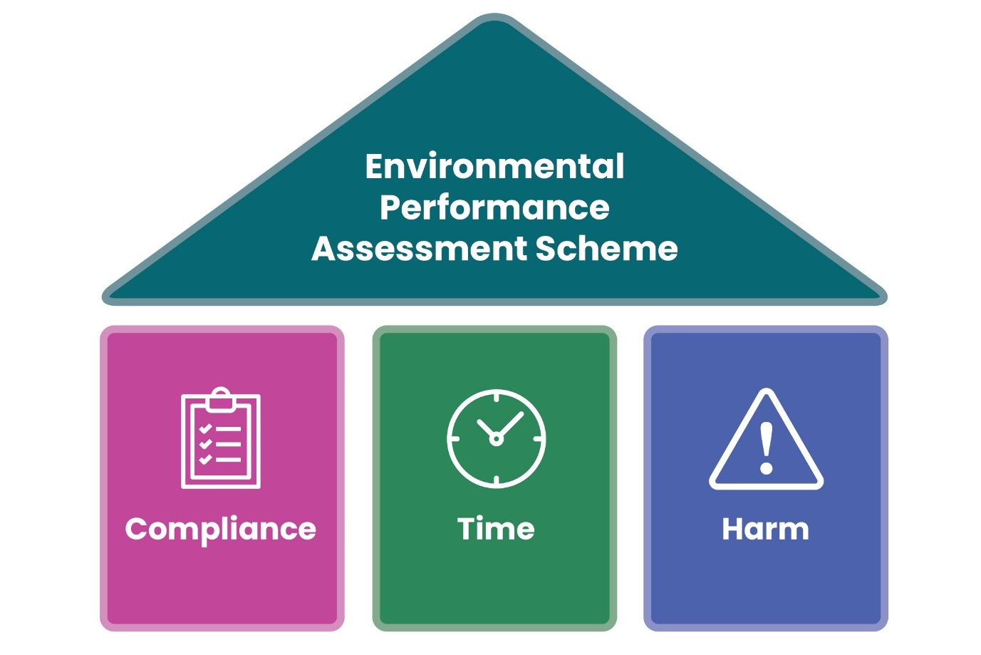**Figure 1: The three parts of EPAS: compliance category, time taken to resolve non-compliance and environmental harm caused**.

We expect all operators to undertake regulated activities in compliance with their financial and legal environmental requirements for that regime including any specific conditions attached to the authorisations they may hold. This includes paying our annual charges on time. This is the minimum that we expect. Our experience is that most operators take these responsibilities seriously.

However, where operators fall below these expectations, we need a robust and clear assessment scheme that allows us to categorise where and why non-compliance has occurred. This includes the actions of the operator to avoid causing environmental harm and resolve any non-compliance quickly.

To reflect this, there will be three parts to the environmental performance rating:

* **Compliance:** how serious any non-compliance was.
* **Time:** how long it took to correct any non-compliance.
* **Environmental harm:** the level of any environmental harm caused.

The environmental performance rating is designed to incentivise good levels of environmental performance and help prevent non-compliance.

An environmental performance rating will have no relationship to any decision we take on whether to take enforcement action where legal requirements have not been met.

The three parts to the environmental performance rating are detailed in Table 1. We think this is a fair way to rate operators.

**Table 1: Information used to calculate the environmental performance rating.**

| **Parts of environmental performance** | **What do we mean?** |
| --- | --- |
| Level of compliance | Was the operator compliant, non-compliant or major non-compliant with their legal environmental responsibilities or conditions attached to the relevant authorisation? |
| Time taken to resolve non-compliance | Was the non-compliance corrected quickly, or did it take months or years to resolve? |
| Environmental harm | Was environmental harm caused equivalent to a Category 1 or 2 environment event? |

To ensure the scheme is simple, understandable and good value to implement, there are three performance ratings, see table 2.

**Table 2: The environmental performance rating and what this means.**

| **Environmental performance rating** | **What does this mean?** |
| --- | --- |
| Good | An operator will either be fully compliant or have some non-compliance that was resolved quickly. |
| Below expectations | An operator may have had an instance of major non-compliance which was resolved quickly or some non-compliance that took a bit longer to resolve. Any environmental harm caused would be a Category 3 or 4 environmental event. |
| Unacceptable | An operator may have had repeat major non-compliance, failed to deal with any non-compliance identified or caused a Category 1 or 2 environmental event. |

Our expectation is all operators attain ‘Good’ environmental performance

When it is not possible to resolve non-compliance immediately, we expect operators to prepare an appropriate compliance recovery plan. When a compliance recovery plan is in place that we have confirmed includes reasonable steps to resolve non-compliance in a timely manner, this will be published alongside the environmental performance rating. This is to ensure we fairly represent the actions operators are taking to achieve compliance.

Our priority is to tackle operators rated as ‘Unacceptable’ with no plan to resolve non-compliance

How level of compliance, time in non-compliance and environmental harm interact to determine the environmental performance rating can be viewed in figure 2. More detail of the environmental performance rules is available in section 9.

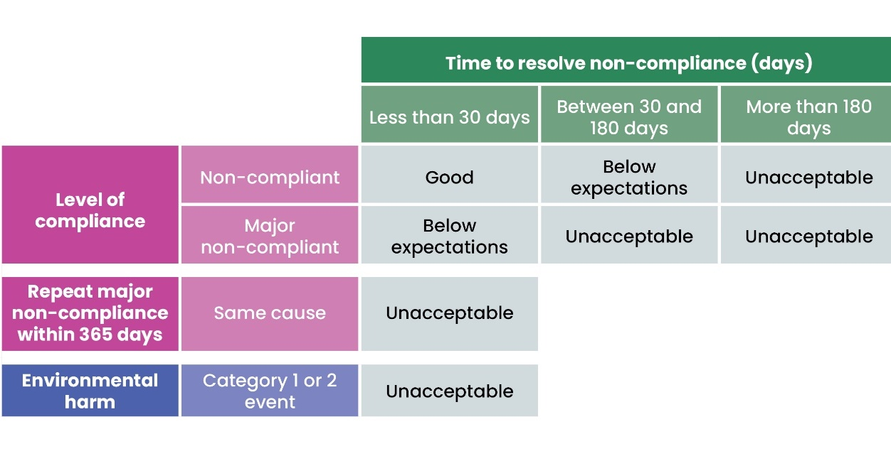

**Figure 2: Environmental performance rating as it relates to level of compliance, time to resolve non-compliance and environmental harm caused.**

We want to ensure that these ratings are easily understood and what the ratings are called both reflects the risk operators pose to the environment and acts as an incentive for operators to proactively avoid any non-compliance with legal environmental requirements.

**Question 1:** How far do you agree or disagree with the three proposed environmental performance ratings of good, below expectations and unacceptable?

# Compliance

Compliance information is one of three parts that determine the environmental performance rating, alongside time taken to resolve non-compliance and environmental harm caused.

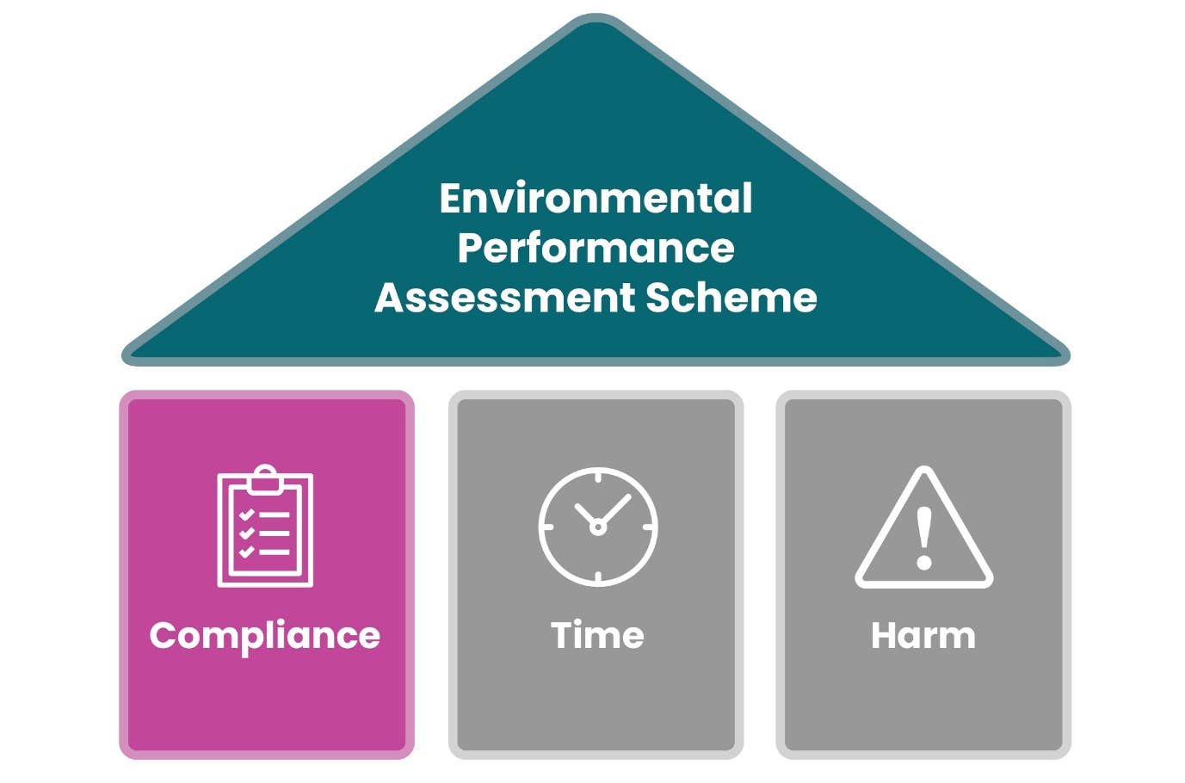**Figure 3: EPAS focus on compliance.**

For EPAS, compliance includes:

* Compliance with legal environmental requirements.
* Compliance with relevant authorisation conditions.
* Compliance with financial requirements (e.g. payment of annual charges).

## How we check compliance

We call checking compliance with legal environmental requirements, compliance verification. We verify compliance according to the better regulation principles set out in the [Scottish regulators’ strategic code of practice](https://www.gov.scot/publications/scottish-regulators-strategic-code-of-practice/): transparent, accountable, proportionate, consistent and targeted only where necessary. We prioritise compliance verification according to the severity of environmental harm a regulated activity could cause and an operator’s compliance history. For some activities we must be present on site or in the field to verify compliance. Other activities can be verified remotely, for example, through review of operator monitoring data.

We verify compliance in two ways:

* **Planned compliance verification**: This includes site inspections at a set frequency, our environmental monitoring programme and operator monitoring data that must be provided at a set frequency.
* **Reactive compliance verification:** This includes site inspections following reports of potential environmental harm received from the public or an operator or indicated by our environmental monitoring programme.

We do not think it is fair to rate an operator’s environmental performance unless we have verified compliance. However, where we verify compliance, we will assess environmental performance.

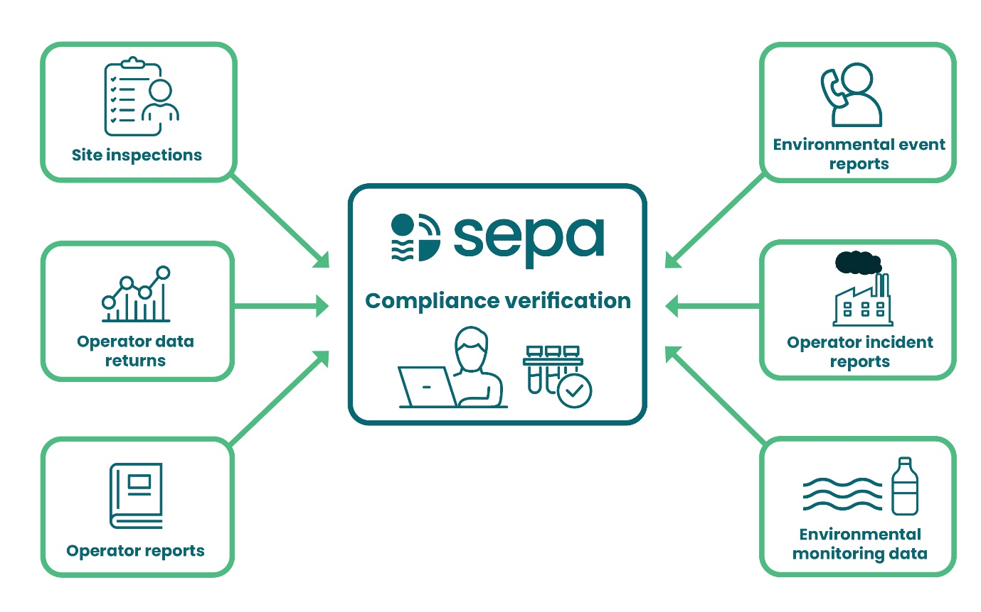**Figure 4: The various ways that we verify compliance.**

## Authorisations included in phase 1 of EPAS

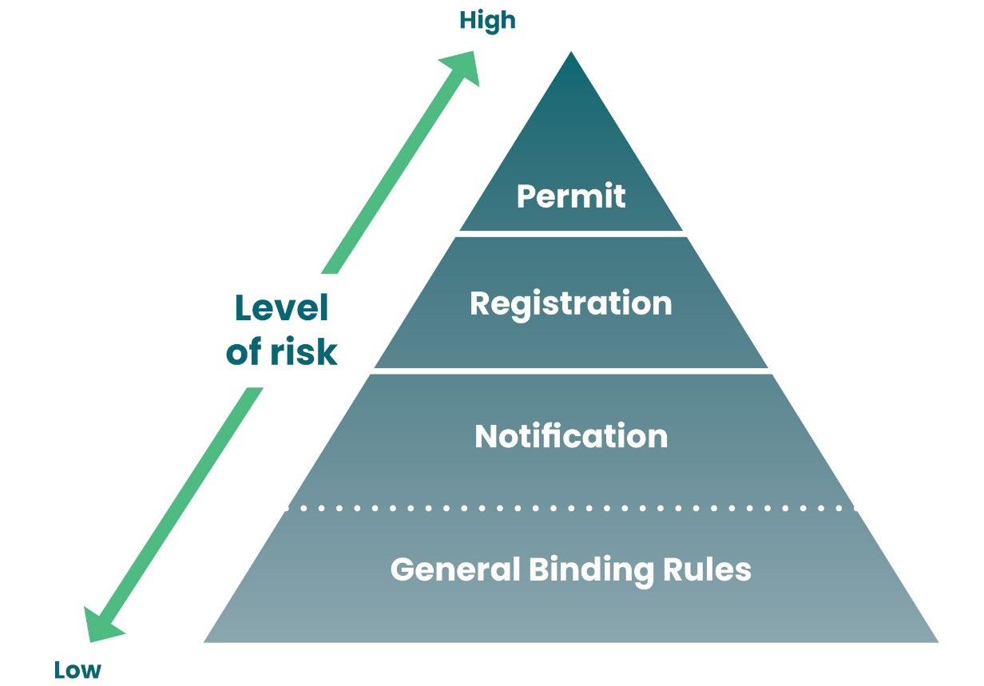

**Figure 5: Authorisation types that a performance rating will be calculated for in phase 1. Performance ratings will only be calculated following compliance verification.**

Authorisations already included or expected to be included in the upcoming amendments to the [Environmental Authorisations (Scotland) Regulations 2018](https://www.sepa.org.uk/regulations/how-we-regulate/environmental-authorisations-scotland-regulations-2018/) and the Integrated Authorisation Framework, planned for November 2025 will be the first to be included in EPAS, see table A1, Annex 1. The type of authorisation required to undertake a regulated activity reflects the level of risk to the environment and the type and frequency of planned compliance verification activities. Our planned compliance verification programme is primarily focused on permit level activities as these are highest risk. However, we also undertake some compliance verification work for registration and notification activities, together with a significant programme of work with respect to rural diffuse pollution General Binding Rule compliance as part of our river basin management plan delivery. Where we carry out compliance verification, we will also rate performance.

## Compliance categories

Compliance is unambiguous – operators are either compliant with the conditions set out in authorisations and/or legal environmental requirements or not. Compliance categories were formally consulted on in 2017. We have been using compliance categories operationally in draft status, together with [major non-compliance criteria](https://www.sepa.org.uk/media/jjbjnh5l/major_non_compliance.pdf), since April 2023. An operator can be categorised as compliant, non-compliant or major non-compliant. If an operator does not provide us with the evidence that we need to assess whether they are compliant, this is categorised as a major non-compliance. Operators are responsible for taking all necessary steps to remain compliant. We have defined the major non-compliance criteria for water, waste, industrial activities and radioactive substances in Annex 3. Late payment of annual charges will be treated as a compliance issue under EPAS, see section 6.8. We will start assessing compliance against our major non-compliance criteria later this year.

**Table 3: Description of compliance categories.**

| **Compliance categories** | **Description** |
| --- | --- |
| Compliant | Full compliance with authorisation conditions, environmental legal requirements and payment of annual charges. |
| Non-compliant | Non-compliance with an authorisation condition and/or environmental legal requirement that is generally of lower environmental significance. Late payment of annual charges. |
| Major non-compliant | Non-compliance with an authorisation condition and/or environmental legal requirement that is of higher environmental significance. Very late or non-payment of annual charges. |

The compliance category is important for the environmental performance rating. If an operator is ‘Major non-compliant' once in a 365-day period, they cannot achieve a ‘Good’ environmental performance rating. If an operator repeats a major non-compliance with the same cause within 356 days, they are rated as ‘Unacceptable’. Causing a Category 1 or 2 environmental event is also always categorised as a ‘Major non-compliance'.

Major non-compliance affects your environmental performance rating

**Question 2:** Do you have any concerns with what we propose to categorise as ‘Major non-compliant’?

## Exclusions

Sample results may be excluded from a compliance assessment under specific circumstances:

* Where we have made errors or mistakes.
* Where discharge sample results meet with the exclusion criteria provided in our regulatory method [WAT-RM-40](https://www.sepa.org.uk/media/152818/wat-rm-40.pdf) Assessment of Numeric Discharge Quality Conditions.
* Where an operator can demonstrate that exclusion of a sample result is appropriate as it is allowed under the authorisation e.g. extreme weather conditionsor situations beyond their control (e.g. vandalism).

## Retrospective changes to a compliance category

There are situations where non-compliance is discovered retrospectively, for example:

* Operator data submitted at year-end shows a mid-year exceedance that we were not notified of at the time; or
* evidence is available that indicates a non-compliance occurred prior to it being identified; or
* evidence provided by an operator is found to be of substandard quality.

In these situations, the operator’s compliance category will be retrospectively changed for the period that the relevant non-compliance occurred.

Similarly, if an operator successfully disputes a compliance decision, their compliance category will be retrospectively changed to reflect this.

Where a compliance category is retrospectively changed, the environmental performance rating will also be changed as soon as reasonably practicable to reflect this.

## When are operators informed about any compliance issues?

When we attend a site in person, where practical we will verbally inform an operator of any compliance issues before we leave the site. This is subject to appropriate personnel being available to speak with us. We will aim to provide a written Compliance Verification Report (CVR) within seven days that informs the operator of the relevant compliance category: ‘Compliant’, ‘Non-compliant’ or ‘Major non-compliant'.

When we need to review data or reports an operator has submitted to us, we will inform operators once this is complete. This review may involve, for example, checks on completeness, format, timeliness and data quality to ensure we can use this evidence with confidence in our compliance assessment. An operator should already be aware if this data identifies any non-compliance. Most authorisations that require the operator data to be provided to us also include a condition that requires the operator to notify us at the time of any non-compliance. Our expectation is that an annual data submission demonstrates that an operator has resolved any compliance issues.

## How long does non-compliance last?

An operator is categorised as ‘Non-compliant’ or ‘Major non-compliant’ until they provide us with satisfactory evidence that they have resolved the relevant compliance issues. It is the operator’s responsibility to do this. Evidence that may demonstrate compliance includes accredited monitoring information, date stamped video and photographs, remote tour etc. We will review the evidence provided and only re-visit a site where necessary to confirm an operator has resolved any compliance issues.

Provided the evidence is subsequently found to be satisfactory, the date an operator will be treated as compliant from will be the date we receive the evidence. It is not the date that we review this evidence to confirm compliance. How long operators remain non-compliant affects their environmental performance rating. It is important to provide evidence of compliance as soon as possible.

It is the operator’s responsibility to demonstrate they are compliant by providing evidence to us

## Annual charges

It is important that operators pay their annual charges, set under our various charging schemes, on time. This enables fair opportunities for all operators, ensures that fees reflect the regulatory effort required and we do not waste time and money trying to recover fees that are due to us. We propose to include consideration of whether subsistence fees have been paid in our assessment of compliance. An operator should not have a ‘Good’ environmental performance rating if they have failed to pay their annual charges.

Late payment of annual charges will be treated as a compliance issue under EPAS. Operators have 30 days to pay an invoice from the date of the invoice. Acknowledging that time can sometimes be required to resolve invoice queries, we propose to categorise an operator as ‘Non-compliant’ if they have not paid an invoice within 90 days of the date of the invoice. If the debt goes into the next financial year or the debt recovery process is initiated, the operator will be categorised as ‘Major non-compliant’. The only exception to this is where an operator has agreed a payment plan with us in advance. The ‘Major non-compliance’ will only be lifted once any annual charges due are paid in full.

We recently consulted on [The Environmental Regulations (Scotland) Charging Scheme 2018: Technical changes - Scottish Environment Protection Agency - Citizen Space](https://consultation.sepa.org.uk/communications/technical-changes/). This includes a proposal that payment of charges under the Environmental Regulations (Scotland) Charging Scheme is a condition of an authorisation.

# Time taken to resolve compliance issues

Time taken to resolve compliance issues is one of three parts that determine the environmental performance rating, alongside the compliance category and environmental harm caused.

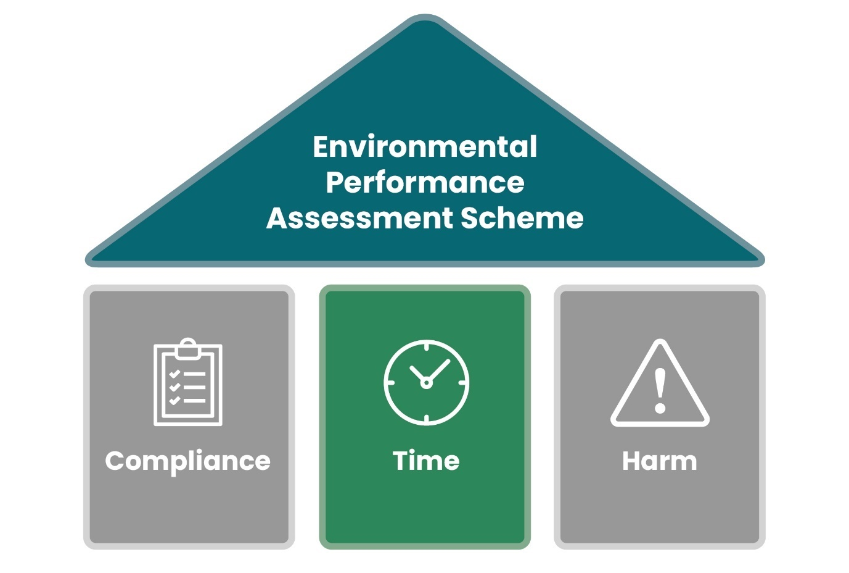**Figure 6: EPAS focus on time.**

How long an operator is ‘Non-compliant’ or ‘Major non-compliant’ for matters. A longer time in ‘Non-compliance’ places the environment at greater risk and undermines other operators that invest to remain compliant. This is not acceptable. The environmental performance rating rewards resolving compliance issues quickly.

We consider that a reasonable time to resolve compliance issues is 30 days from when the issue was identified. Operators who have some non-compliance i.e. not major non-compliance and resolve this within 30 days can retain an environmental performance rating of ‘Good’. If it takes more than 30 days to resolve, but less than 180 days (roughly six months) then the environmental performance rating is downgraded to ‘Below expectations’. Anything longer than six months is ‘Unacceptable’.

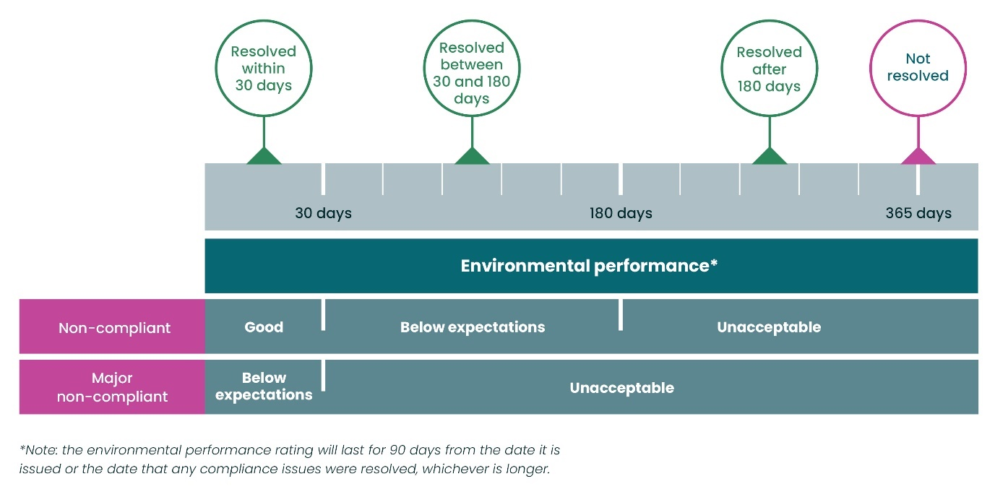**Figure 7: How long an operator takes to resolve a compliance issue affects their environmental performance rating.**

We know that in some instances, significant capital expenditure is required to comply, together with complex design and build solutions and that this can often span a multi-year period. Simply put, it is not possible to resolve within 180 days. In these instances, we expect operators to prepare an appropriate compliance recovery plan. When a compliance recovery plan is in place that we have confirmed includes reasonable steps to resolve non-compliance in a timely manner, this will be published alongside the environmental performance rating. This provides a transparent picture to those who use environmental performance ratings and ensures actions operators are taking to resolve non-compliance are fairly represented.

How quickly an operator resolves compliance issues will impact their environmental performance rating

**Question 3**: How important do you think it is to include the length of time taken to resolve compliance issues within the environmental performance assessment?

**Question 4:** In your view, how many days should an operator have to resolve an issue categorised as ‘Non-compliant’ and still retain a ‘Good’ performance rating?

**Question 5:** How many days should an operator have to resolve an issue categorised as ‘Non-compliant’ before their environmental performance is rated as ‘Unacceptable’?

**Question 6:** How many days should an operator have to resolve an issue categorised as ‘Major non-compliant’ before their environmental performance is rated as ‘Unacceptable’?

# Environmental harm caused

Environmental harm caused is one of three key areas that determine the environmental performance rating, alongside compliance category and time taken to resolve non-compliance. If an operator causes a Category 1 or 2 event, their environmental performance rating will be ‘Unacceptable’.

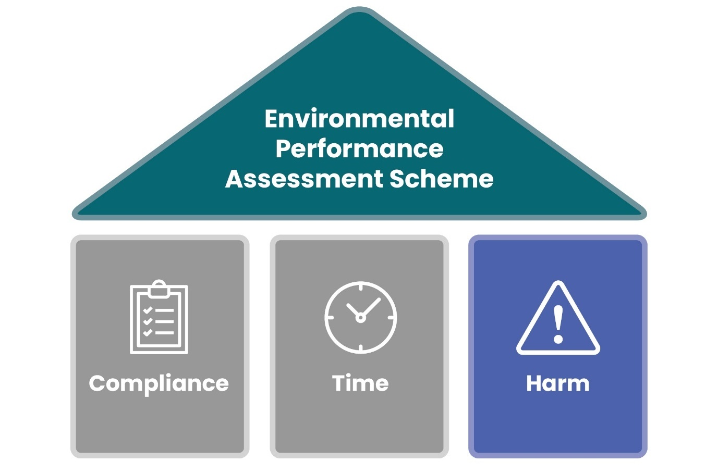**Figure 8: EPAS focus on environmental harm.**

## Environmental harm

For environmental events, we use the definition of environmental harm set out in the Regulatory Reform (Scotland) Act 2014 (see Annex 4).

Compliance with authorisation conditions and legal environmental requirements, which are set to protect the environment, should prevent unacceptable environmental harm occurring from regulated activities under normal circumstances.

## Environmental events

For the purposes of EPAS, an environmental event is an incident that has either caused or is likely to have caused environmental harm. By “is likely to have caused” we mean there is evidence of an incident that is likely to cause environmental harm, even if the specific effects cannot be directly measured. For example, this may apply to discharges of toxic chemicals into groundwater or the seabed, such as from a long-sea outfall. It could also mean that the scale of an event is such that it is likely environmental harm will have been caused, but it would be prohibitively expensive to obtain physical evidence, or equipment that should have gathered the required data was malfunctioning at the time.

For EPAS, we only include environmental events that are caused by activities where we are the relevant regulatory authority. We do not include events where another statutory body is the relevant regulatory authority, such as discharges to sewers or breaches of Health & Safety requirements, although we do work in partnership with other statutory bodies where appropriate. It does not apply to naturally occurring events such as pollen deposits, volcanic dust, fish mortality from naturally occurring high temperatures or lightning strikes, or natural river foaming.

Environmental events may be caused by equipment malfunction, an accident, an inappropriate activity, or any other incident.

We categorise environmental events according to the severity of environmental harm caused, see Figure 9. We have recently reviewed our environmental events categorisation and plan to start using these new categories when our major non-compliance criteria come into effect. The new categories are included as Annex 4.

A diagram of a level of effects that correspond with each category of environmental event.



**Figure 9: Environmental event categories.**

Category 1 and 2 represent more serious environmental events. If an operator causes environmental harm at the level of a Category 1 or 2 environmental event, this will automatically result in an ‘Unacceptable’ environmental performance rating. This means, even if the issues that caused the major non-compliance are resolved quickly, a ‘Below expectations’ environmental performance rating cannot be retained.

Category 3 environmental events will result in a ‘Non-compliant’ category. More than four Category 3 environmental events with the same cause in twelve months will result in a ‘Major non-compliant’ category.

## Exacerbating and mitigating factors

Some environmental events will be more or less serious as a result of the sensitivity of receptors or impact to communities. Similar incidents can have widely differing impacts due to the nature of the environment in which they happen and the local or wider circumstances. For instance, an unauthorised abstraction during periods of high flows will have a lower impact than an unauthorised abstraction during a period of water scarcity. These factors will form part of the environmental event category assessment and may result in environmental events that initially seem to be comparable falling into different environmental event categories. It is important that both we and operators take the environmental circumstances into account while assessing environmental harm. Exacerbating and mitigating factors are detailed in Annex 4.

Causing serious environmental harm is always rated as ‘Unacceptable’

**Question 7:** Do you understand what a Category 1 or 2 environmental event is?

**Question 8:** How far do you agree or disagree that causing a Category 1 or 2 environmental event should always be considered ‘Unacceptable’ environmental performance?

# Applying the Environmental Performance Assessment Scheme (EPAS)

## EPAS rules

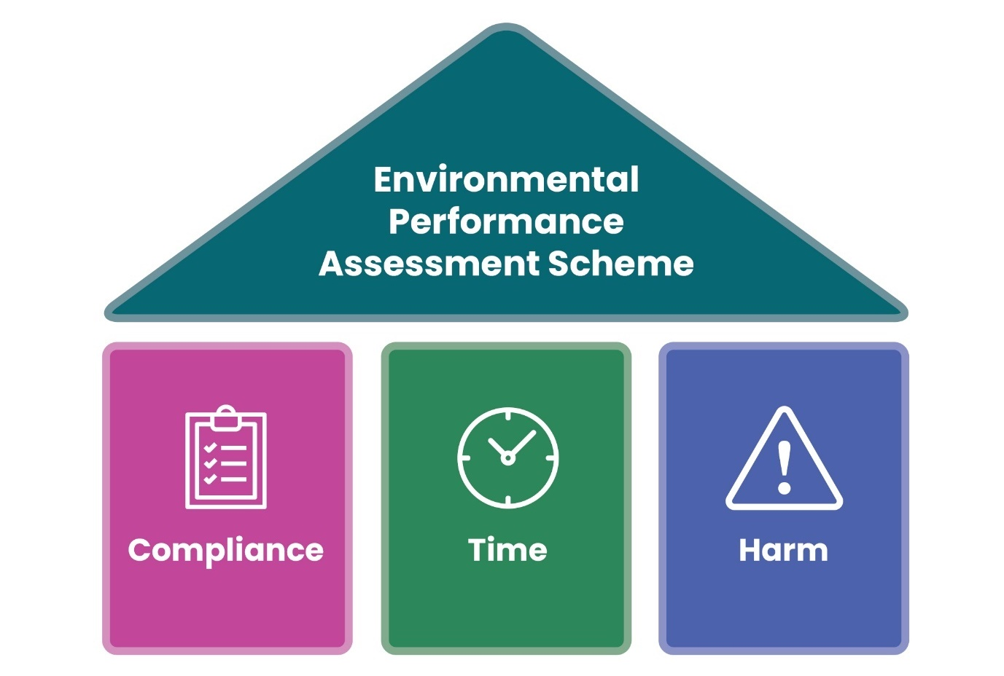**Figure 10: The three parts of EPAS.**

The environmental performance rules can be viewed in figure 2, section 5 and table 4 below. We think these rules are fair and proportionate. There are three parts to environmental performance: compliance category, time taken to resolve non-compliance and environmental harm caused and the rules reflect these.

**Compliance:** One major non-compliance means the best rating an operator can achieve is ‘Below expectations’. A repeat major non-compliance of the same authorisation condition demonstrates appropriate action to avoid this happening again was not taken, so the best rating an operator can achieve is ‘Unacceptable’.

**Time:** Taking longer than 30 days to resolve a compliance issue would result in an environmental performance rating being downgraded (from ‘Good’ to ‘Below expectations’ or from ‘Below expectations’ to ‘Unacceptable’). Taking longer than 180 days (approximately 6 months) to resolve a compliance issue downgrades the environmental performance rating from ‘Below expectations’ to ‘Unacceptable’.

**Environmental harm:** Causing a Category 1 or 2 environmental event equates to ‘Unacceptable’ environmental performance.

**Table 4: Overview of the environmental performance rules and associated environmental performance rating.**

| **Number** | **Environmental performance rules** | **Environmental performance rating** |
| --- | --- | --- |
| 1 | No compliance issues identified. | **GOOD** |
| 2 | **Non-compliance** identified and resolved within 30 days. | **GOOD** |
| 3 | **Non-compliance** identified that took between 30 and 180 days to resolve. | **BELOW EXPECTATIONS** |
| 4 | **Non-compliance** identified that took more than 180 days to resolve. | **UNACCEPTABLE** |
| 5 | **Major non-compliance** identified and resolved within 30 days. | **BELOW EXPECTATIONS** |
| 6 | **Major non-compliance** identified that took more than 30 days to resolve. | **UNACCEPTABLE** |
| 7 | **Major non-compliance** where the same cause is repeated*. | **UNACCEPTABLE** |
| 8 | Caused a Category 1 or 2 environmental event. | **UNACCEPTABLE** |

* A 365 day look back will be used to calculate when a repeat compliance issue occurs.

## When will the environmental performance rating be calculated and how long will it last?

The environmental performance rating is always calculated and published at the end of the 28-day appeals window (see section 11: Appeals), even if an operator is found to be fully compliant following compliance verification. To ensure real-time relevancy the environmental performance rating will last for:

* 90 days from the date it is published OR,
* If any compliance issues are not resolved by this date, the rating will be extended until the date that we receive evidence that all compliance issues are resolved.

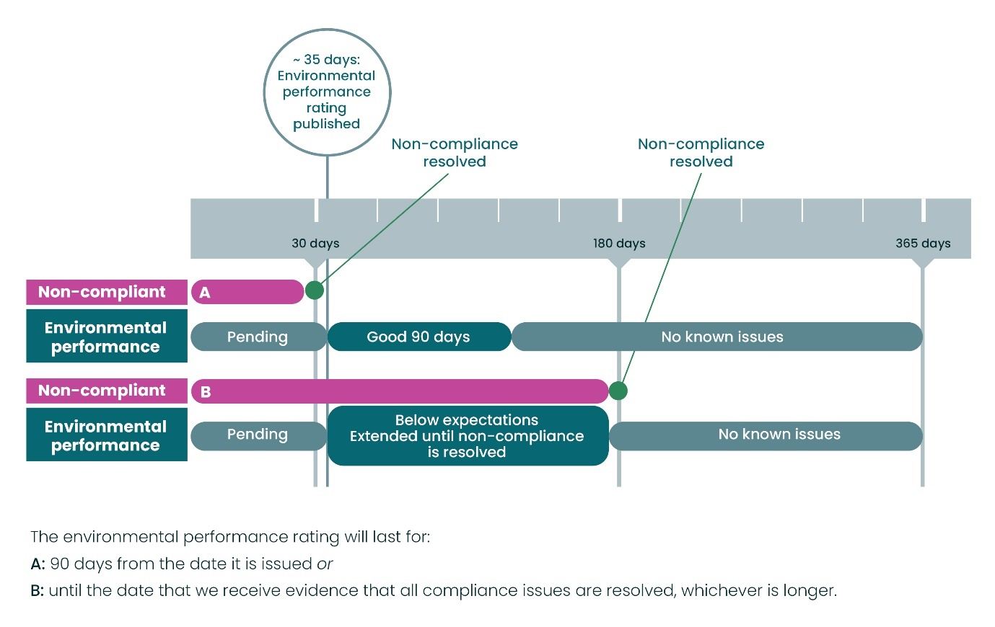**Figure 11: How long an environmental performance rating lasts depends on how long it takes an operator to resolve any compliance issues.**

We need to be confident that when we publish a ‘Good’, ‘Below expectations’ or ‘Unacceptable’ environmental performance rating, this reflects current environmental performance. This responsive approach is designed to incentivise action. The longer an operator takes to resolve any non-compliance, the longer their environmental performance rating is negatively impacted. If an operator acts quickly to resolve issues, it makes sense that their environmental performance rating is not impacted for an unnecessarily long time period (e.g. until our next compliance verification inspection enables a reassessment of environmental performance). We consider that 90 days is an appropriate period for an environmental performance rating to remain in place.

To indicate when an environmental performance rating is expected and when it is no longer valid, an environmental performance rating status is provided. This is set out in Table 5. The environmental performance rating status will revert to: ‘No known issues’following the relevant 90-day period (from the publication date or the date any non-compliance was resolved).

To ensure real time relevancy the environmental performance rating will last for 90 days from the date of publication or until the date we receive evidence that any compliance issues are resolved

**Table 5: Environmental performance rating status and what this means.**

| **Environmental performance rating status** | **What does this mean?** | **Why is this beneficial?** |
| --- | --- | --- |
| Pending | A compliance verification activity has been carried out and an environmental performance rating is expected to be published within the next 35 days. | It is transparent that an environmental performance rating is expected to be published soon. |
| Suspended – pending appeal outcome | A compliance verification activity has been carried out, but some or all aspects are under appeal. | It is transparent that the environmental performance rating is under appeal and the outcome is not yet known. |
| No known issues | The environmental performance rating is no longer valid. The compliance issues causing an operator to previously be rated as ‘Below expectations’ or ‘Unacceptable’ were resolved, or it has been 90 days since the environmental performance rating was published. A site remains in this status until the next compliance verification activity takes place. | It is a fair and accurate reflection of the situation. It would be inappropriate to default to ‘Good’ performance. For example, if an operator takes a long time to resolve non-compliance, we cannot assume that there are no new compliance issues on the site. A reassessment of performance would only be generated via the next planned or reactive compliance verification activity. |

## Worked examples

The examples below demonstrate how quick action by operators can achieve a better environmental performance rating.

### Example 1

* Our compliance verification finds an operator to be ‘Non-compliant’.
* The operator takes 20 days to resolve the non-compliance.
* The operator is rated as ‘Good’.
* The ‘Good’ environmental performance rating lasts for 90 days.
* The environmental performance rating expires and reverts to ‘No known issues’ status, see figure 12.

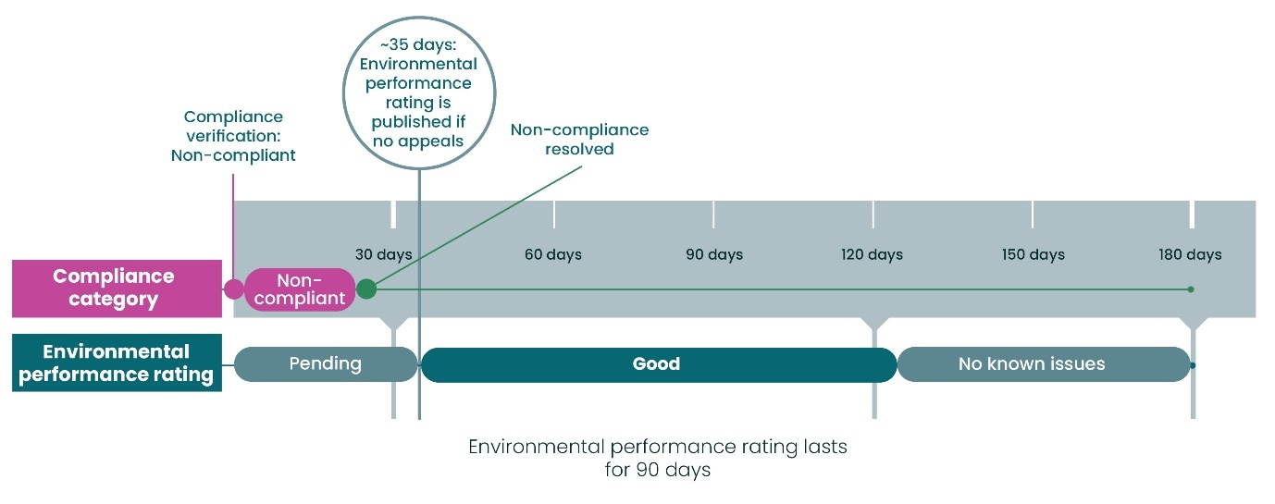

**Figure 12: How an operator would be rated where they quickly resolved an issue categorised as ‘Non-compliant’ (example 1).**

### Example 2

* Our compliance verification finds an operator to be ‘Major non-compliant’.
* The operator takes 25 days to resolve the major non-compliance.
* The operator is rated as ‘Below expectations’.
* The ‘Below expectations’ environmental performance rating lasts for 90 days.
* The environmental performance rating expires and reverts to ‘No known issues’, see figure 13.

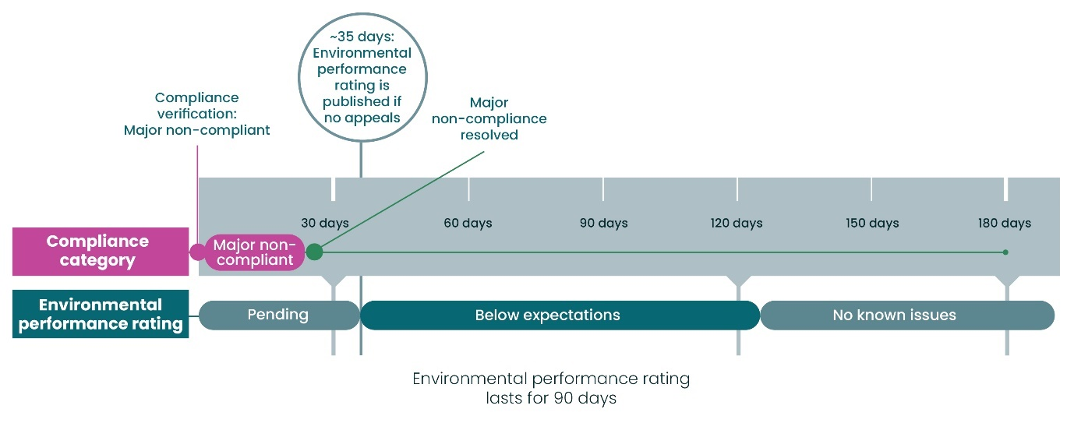

**Figure 13: How an operator would be rated where they quickly resolved an issue categorised as’ Major non-compliant.**

### Example 3

* Our first compliance verification finds an operator to be ‘Non-compliant’.
* The operator takes 160 days to resolve the non-compliance.
* The operator is rated as ‘Below expectations’.
* The ‘Below expectations’ environmental performance rating lasts for 125 days.
* The environmental performance rating expires and reverts to ‘No known issues’, see figure 14.
* Our second compliance verification finds an operator to be ‘Compliant’.
* The environmental performance rating status changes to ‘Pending’ to indicate an environmental performance rating is due once the time allowed for any appeals has expired.
* The operator is rated as ‘Good’.
* The ‘Good’ environmental performance rating lasts for 90 days.
* Environmental performance rating expires and reverts to ‘No known issues’ (this step is not shown on figure 14).

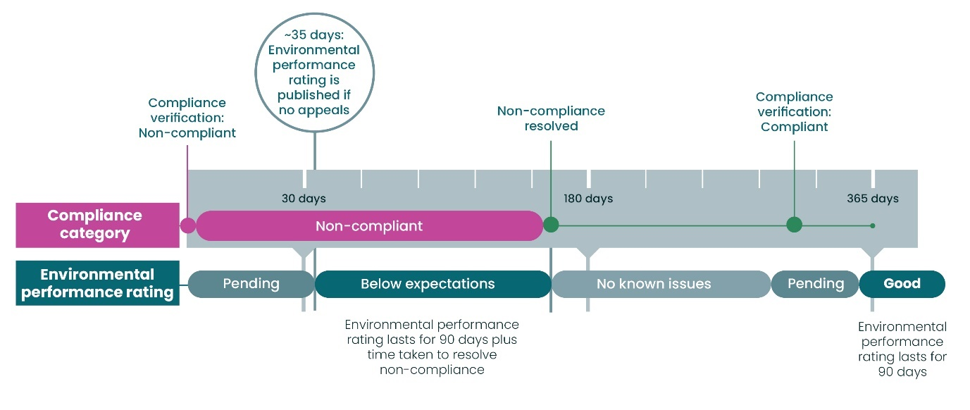**Figure 14: Consequences of not resolving an issue categorised as ‘Non-compliant’ for a longer time and the benefits of a performance rating lasting for 90 days or, until we receive evidence that any compliance issues are resolved.**

## Environmental performance and enforcement

Environmental performance ratings have no relationship to any decision we take on whether or not to take enforcement action in respect of any breach of legislation. Decisions on enforcement are taken in line with our [enforcement policy](https://www.sepa.org.uk/media/219244/enforcement-policy.pdf) and [enforcement guidance](https://www.sepa.org.uk/media/219242/enforcement-guidance.pdf). We assess the specific situation against the factors and guidance contained within that policy and Guidance. We will continue to target operators who persistently refuse to comply and who cause environmental harm.

**Question 9:** How well do you understand how we are proposing to assess environmental performance?

**Question 10:** How far do you agree or disagree that real time relevancy is important to enable everyone to take decisions based on an operators’ environmental performance rating?

**Question 11:** How far do you agree or disagree that the duration of 90 days is an appropriate timescale for an environmental performance rating to enable real time relevancy?

**Question 12:** How fair is a 365-day lookback period for assessing repeat compliance issues?

**Question 13:** How fair do you think the proposed Environmental Performance Assessment Scheme is?

# Priority site status and compliance recovery plans

We plan to identify sites where the relevant operator remains ‘Unacceptable’ for more than 90 days as a ‘Priority site’. This is to reflect the ongoing impact to the environment and communities, and to act as a driver for the operator to improve their environmental performance.

A priority site designation is important – our intention is to publish proactively and raise awareness of the operators of these sites.

Once an operator has been rated as ‘Unacceptable’ in relation to a specific site, they will have a maximum of 90 days to prepare a **compliance recovery plan** and have thisconfirmed by us as containing reasonable steps to resolve any non-compliance in a timely manner. If that is achieved, the relevant site will not be added to the priority site list. However, if the non-compliance is continuing to cause more substantial environmental harm such as a Category 1 or 2 environmental event, the site will remain on the priority site list, even if the relevant operator has a compliance recovery plan in place.

If an operator rated as ‘Unacceptable’ in relation to a specific site fails to deliver against a compliance recovery plan without prior agreement from us, they will be published on the priority sites list.

Priority sites are sites that are ‘Unacceptable’ for more than 90 days with no compliance recovery plan in place

SEPA will actively raise awareness of priority sites on an ongoing basis

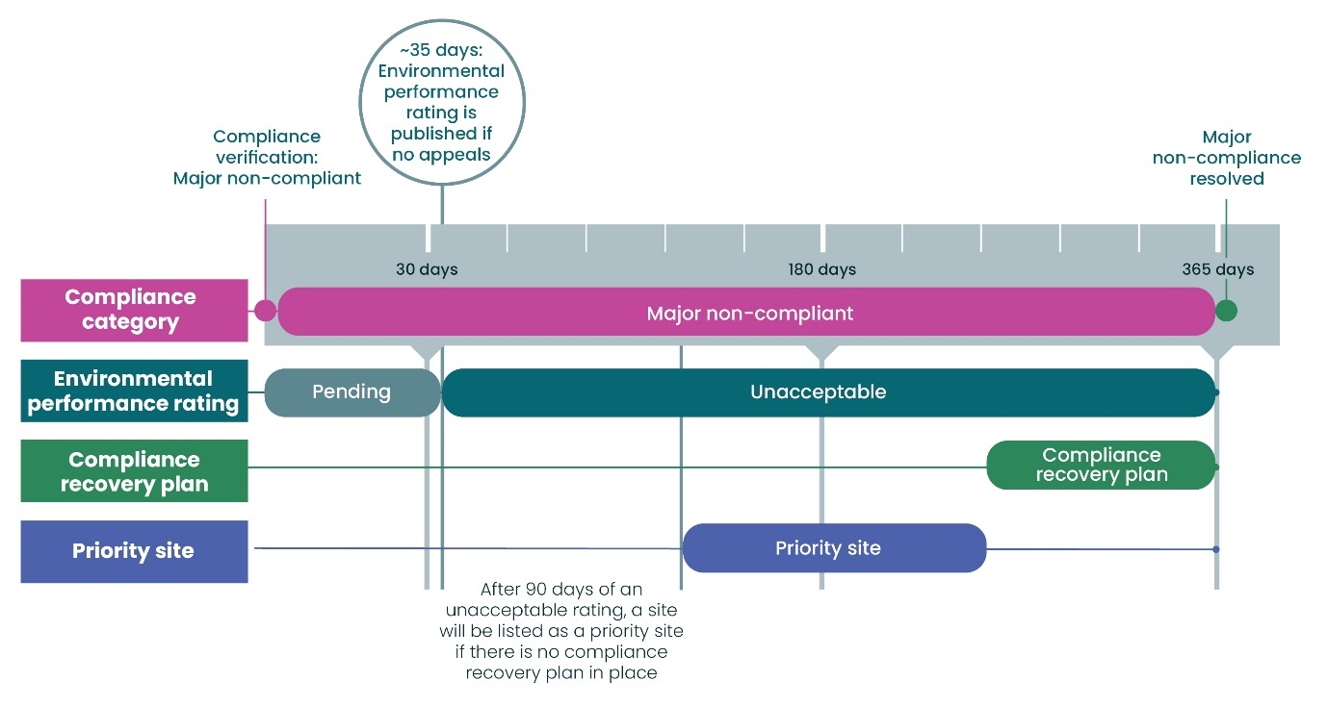

**Figure 15: If an operator’s site is rated as ‘Unacceptable’, it will be listed as a priority site, if no compliance recovery plan is agreed within 90 days. Once an agreed compliance recovery plan is in place, it will be removed from the priority site list.**

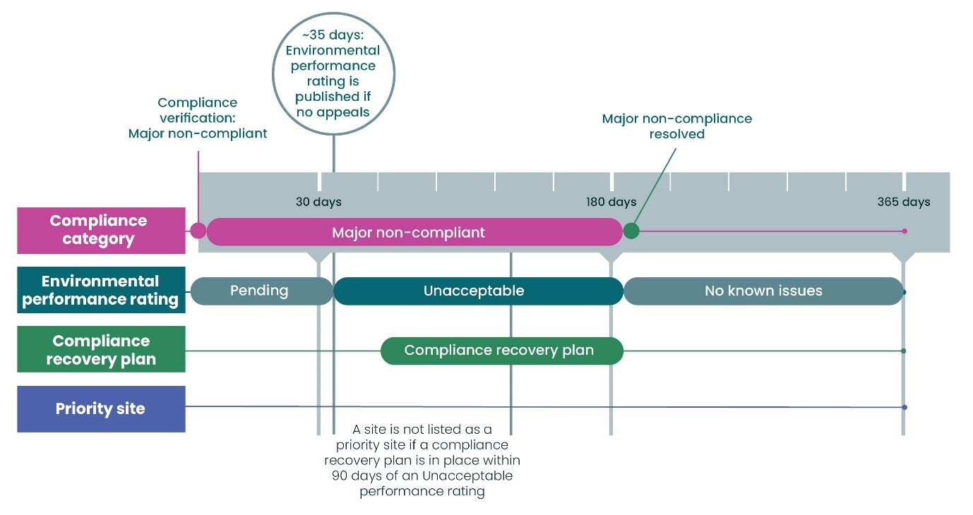

**Figure 16: If an operator’s site is rated as ‘Unacceptable’ and a compliance recovery plan is agreed within 90 days, it will not be listed as a priority site.**

**Question 14:** How far do you agree or disagree that publishing a priority sites list would drive improvements in performance?

**Question 15:** How long should an operator have to establish a compliance recovery plan before a site rated as unacceptable is listed as a ‘Priority site’?

# Appeals

We want EPAS to be fair and transparent. An ability to appeal decisions that impact an operator is therefore built into the system. We are proposing to implement a three-step appeals process covering the following decisions:

* Compliance category (limited to ‘Non-compliant’ and ‘Major non-compliant’).
* Decision that a compliance recovery plan does not contain reasonable steps to resolve the relevant non-compliance in a timely manner, (limited to situations where this would result in publication as a ‘Priority site’).

Operators will have a period of up to 28 days to appeal following:

* Receipt of a compliance verification report that highlights non-compliance or
* Our decision that a compliance recovery plan does not contain reasonable steps to resolve the relevant non-compliance in a timely manner.

If this isn’t challenged within 28 days, then the environmental performance rating will automatically be calculated and published.

### Appeal step 1: Frontline resolution

The operator can seek clarification or provide additional information to the assessing officer and ask for a decision to be reconsidered.

Our priority is resolving as much as possible at this stage. We recognise step 1 can involve two-way dialogue over a short period whilst issues are discussed and resolved.

Clarification may be required across the three parts of environmental performance: compliance, time to resolve non-compliance and environmental harm caused. Our major non-compliance criteria and environmental events guidance will help provide operators with clarity and reduce the need to seek clarification.

The officer will review their decision and then either confirm that they consider their initial decision to be a correct one or change that decision accordingly. Should the operator still not be satisfied with the outcome, they can move immediately to step 2.

### Appeal step 2: Management review

The operator can ask that a manager review all material facts to ensure that the decision was fairly and appropriately made. This will ordinarily be a manager within the same functional area of our organisation. Particular care will be given to ensure that a decision is consistent with relevant processes and procedures and with other similar decisions in so far as relevant. The manager will provide a response in writing, either upholding or changing the decision of the officer. Should the operator still not be satisfied with the outcome they can move immediately to step 3.

### Appeal step 3: Formal appeal

The formal appeal stage is the final step in the process. In this step the operator seeks a re-evaluation of the original decision. At this stage, we will appoint a member of staff to manage the appeal and to make a decision on the merits, considering afresh the relevant facts, law, policy or guidance. That person will be independent of the original decision maker and their management chain. All information will be provided to the person managing the appeal. They will have the ability to seek further information from the operator, officer, manager or any other person necessary to reach their decision. The decision of the person handling the appeal will be final.

Where an operator appeals our decision on their compliance category, we will still calculate and publish the environmental performance rating on the EPAS system dashboard but make clear this is suspended pending appeal outcome e.g. ‘Below expectations – suspended pending appeal outcome’. For operators with sites that are rated as ‘Unacceptable’ and where we have decided that the proposed compliance recovery plan does not contain reasonable steps to resolve the relevant non-compliance in a timely manner and this decision is then appealed, we will still publish as a priority site, but make clear that our assessment of the acceptability of the compliance recovery plan is under appeal.

The proposed appeal process does not in any way exclude the ability for the operator to raise a service level complaint through our [complaints handling procedure](https://beta.sepa.scot/about-sepa/how-we-work/complaints-handling-procedure/).

An operator will have 28 days to submit an appeal before the environmental performance rating is published

**Question 16:**  How far do you agree or disagree our proposed appeals process is fair?

# How we will communicate relevant information

## What information will be available on our website?

To be as open and transparent as possible, we plan to put as much information about EPAS as possible into the public domain. Annually, we receive numerous requests for compliance information and to ensure best value for public finance, it is more efficient to make it fully accessible from the outset (other than where there are legal reasons why information cannot be published)*.*

Generally, compliance verification reports will be made available on our [Public Register](https://www.sepa.org.uk/regulations/authorisations-and-permits/public-register/). We will also show the current and previous compliance categories as we have described in section 6.3. We will make clear to all users that whilst this basic compliance information informs the environmental performance rating, a compliance category is not representative of performance and should not be considered in isolation. It should only be interpreted through a performance lens.

How and what we communicate will be user led and designed to [Digital Scotland Service Standard](https://servicemanual.gov.scot/browse/digital-scotland-service-standard) criteria. However, an example of the kind of information we intend to make available is shown in Figure 17. The environmental performance rating provides the best indication of how an operator is doing from an environmental perspective and is the information that we will use to inform where we direct our regulatory effort. The compliance information is only part of the story but will be included for transparency, alongside links to relevant compliance verification reports held on the public register.

When we publish information, we will make clear that users should focus on the environmental performance rating

]

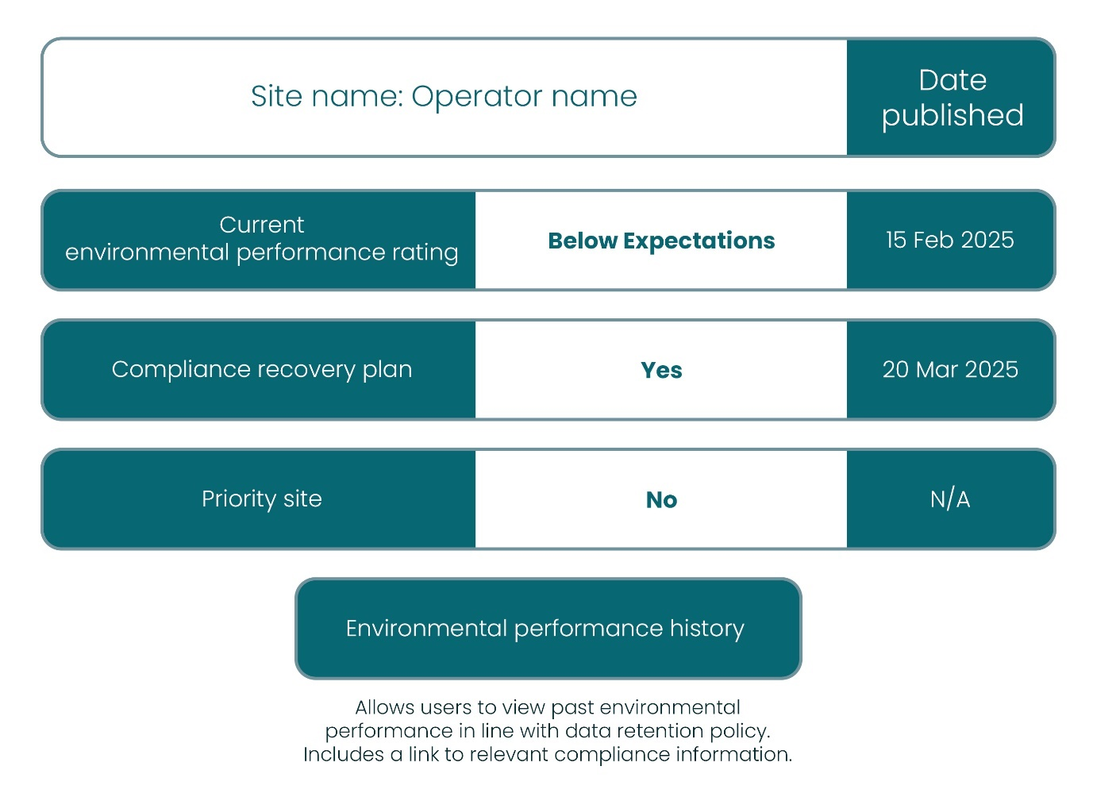**Figure 17: Example of the kind of information that will be made available for the environmental performance rating. Please note that we will undertake user testing to determine how best to display this information and what should be displayed.**

Supporting information that informs environmental performance includes:

### Compliance

* Current compliance category (‘Compliant’, ‘Non-compliant’ or ‘Major non-compliant').
* Previous compliance category (‘Compliant’, ‘Non-compliant’’ or Major non-compliant').
* Compliance recovery plan in place if applicable (yes or no).

### Time

* Date that any current compliance issues were identified if not yet resolved (Date of last compliance verification activity where compliance issues are ongoing).
* Date any compliance issues were resolved (if applicable).
* Date of last compliance verification activity.
* Year when next compliance verification is expected (financial year).
* Overall number of days an operator has been ‘Non-compliant’ or ‘Major non-compliant’.

### Environmental harm

* Category 1 or 2 environmental event caused (yes or no).

A detailed overview of environmental performance together with the underlying compliance data will be publicly available on our website

## Digital systems

Our long-term vision is to develop a single online platform that allows operators to interact with all aspects of their regulatory journey with us end-to-end. Operators will be able to contact and access all information and guidance on this single platform. From a compliance perspective operators will be able to upload data returns and other information that is required to be submitted to comply with the conditions attached to an authorisation. It will provide the ability to submit an appeal against the outcome of a compliance verification activity.

From a compliance and environmental performance perspective we want operators to be able to see their information in real-time and proactively take any required action.

We are at the early days of developing requirements for this platform, but we want to hear what would most benefit you as a future user of this digital system.

We want to develop digital systems that benefit all users

**Question 17:** What would you like to be able to do on an online platform to interact with us?

# Next steps to launch EPAS

## Timeline for EPAS

**2025 to 2026:** We will start applying the major non-compliance criteria and environmental events framework as soon as practicable following this consultation. However, we would encourage all operators to familiarise themselves with these criteria and start working in this way now.

**Following this consultation and ongoing:** We will be developing new digital systems to make it easier to submit, review and access compliance and environmental performance information. This will be user-led and will include user-testing.

**March 2026:** We will confirm how EPAS will operate and timescales for implementation of EPAS.

**2026 to 2027:** We will provide quarterly progress updates on EPAS on our website and will provide six months’ notice before we implement EPAS.

**2027 onwards:** Inclusion of other regulatory regimes on a phased basis.

## Review periods

We propose to keep EPAS under active review when we implement the scheme. For example, a natural point to review our major non-compliance criteria is when standard permit conditions are introduced for water, waste and industrial activities regimes under the forthcoming amendments to the Environmental Authorisations (Scotland) Regulations 2018.

**Question 18:** Do you think the overall impact of EPAS for Scotland’s environment will be:

* Extremely positive
* Mostly Positive
* Minimal or neutral impact
* Don’t know
* Mostly negative
* Extremely negative

**Question 19:** What impact do you think EPAS will have on your business or organisation?

We recognise that some operators voluntarily go beyond legal requirements to reduce their impact to the environment and tackle pressing challenges such as biodiversity loss and climate change. We are considering whether EPAS should include a rating that acknowledges and recognises these proactive efforts, and if so, how this could work in practice.

**Question 20:** How important do you think it is that EPAS should recognise voluntary actions that go beyond compliance?

**Question 21:** What factors should we consider if we were to introduce a performance rating that acknowledges these proactive efforts?

**Question 22:** Do you have any other important suggestions, opportunities or concerns around EPAS that you would like to highlight?

# Annex 1: Regimes proposed to be included in phase one of EPAS

**Table A1: Regimes included when the EPAS launches. Some regimes include more activities than those listed in this summary table.**

| **Regime** | **Description of controlled activities** | **Relevant Laws** |
| --- | --- | --- |
| [Water](https://www.sepa.org.uk/regulations/water/) | Aquaculture: fish farming in freshwater or sea pens.  Water resources: taking, diverting or storing water (abstractions and impoundments).  Engineering: modifying or building in or near to inland water environments.  Discharge of substances to the water environment, including water at temperatures that may cause environmental harm. | [The Water Environment (Controlled Activities) (Scotland) Regulations 2011](https://www.legislation.gov.uk/ssi/2011/209/contents/made) as amended in [2013](https://www.legislation.gov.uk/ssi/2013/176/contents/made), [2017](https://www.legislation.gov.uk/ssi/2017/389/pdfs/ssi_20170389_en.pdf) and [2021](https://www.legislation.gov.uk/ssi/2021/412/contents/made). We call this CAR. |
| [Industrial activities](https://www.sepa.org.uk/regulations/pollution-prevention-and-control/) | Release of substances to air, water and land from industrial activities e.g. energy, chemical and mineral industries, food and drink production including intensive agriculture and many more. | [The Pollution Prevention and Control (Scotland) Regulations 2012](https://www.legislation.gov.uk/ssi/2012/360/contents/made). We call this PPC. |
| [Waste Management](https://www.sepa.org.uk/regulations/waste/) | Storage and treatment of waste e.g. transfer stations (for both household and commercial waste), metal recycling centres (‘scrap yards’), green waste compositing sites. | [Waste Management Licensing (Scotland) Regulations 2011](https://www.legislation.gov.uk/sdsi/2011/9780111012147/contents). We call this Waste Management Licences. |
| [Radioactive Substances](https://www.sepa.org.uk/regulations/radioactive-substances/) | Management of radioactive substances including decommissioning sites and radioactive waste. | [Environmental Authorisations (Scotland) Regulations 2018](https://www.legislation.gov.uk/sdsi/2018/9780111039014/contents). We call this EASR. |

# Annex 2: Regimes planned for inclusion in EPAS in future

**Table A2: Other regimes that include activities that we regulate and are intended to be included in EPAS in future.**

| **Regime** | **Description of controlled activities** | **Relevant legislation** |
| --- | --- | --- |
| [Deposit Return Scheme](https://www.sepa.org.uk/regulations/waste/deposit-return-scheme/)  (DRS) | Forthcoming requirement to operate a refundable deposit system for single use drinks containers. Obligations will apply to any person who produces, imports, markets or sells in-scope single use containers to Scottish consumers.  DRS will be overseen by a scheme administrator who will have key regulatory obligations. | [The Deposit and Return Scheme for Scotland Regulations 2020](https://www.legislation.gov.uk/ssi/2020/154/contents/made) as amended in [2022](https://www.legislation.gov.uk/ssi/2022/76/contents/made) and [2023](https://www.legislation.gov.uk/ssi/2023/201/contents/made) and 2025.  The Deposit and Return Scheme for Scotland (Designation of Scheme Administrator) Order 2025. |
| Digital Waste Tracking | Mandatory requirement to use UK Digital Waste Tracking Service to allow waste movements to be tracked across the UK, help waste producers and waste managers comply with their Duty of Care, and notify SEPA of Green List Waste exports. | *Digital Waste Tracking (Scotland) Regulations – under development.* |
| Duty of Care | Duties contained in s34 of the Environmental Protection Act 1990, that must be complied with by anyone who produces, keeps, imports, or manages controlled waste in Scotland. Further guidance on these obligations can be found in the statutory code of practice:  [Duty of care: code of practice for managing controlled waste.](https://www.gov.scot/publications/duty-care-code-practice/documents/) | [Environmental Protection Act 1990 (as amended)](https://www.legislation.gov.uk/ukpga/1990/43/contents)  [Waste (Scotland) Regulations 2012 (as amended)](https://www.legislation.gov.uk/sdsi/2012/9780111016657/contents) |
| [Emissions Trading Scheme](https://www.sepa.org.uk/regulations/climate-change/uk-emissions-trading-scheme/) | Activities that produce greenhouse gases like carbon dioxide or nitrous oxide. Includes energy industries, production and processing of metals, mineral industries e.g. production of cement, lime, glass, glass fibre, timber processes, production of acid or chemicals. | [The Greenhouse Gas Emissions Trading Scheme Order 2020](https://www.legislation.gov.uk/uksi/2020/1265/schedule/2/made) |
| [Fluorinated gases](https://www.sepa.org.uk/regulations/climate-change/f-gases-and-ods/)  (F gases) | F gases are powerful greenhouse gases.  Operators who:   * Use or service equipment that contains F gases, like refrigeration and air conditioning systems, solvents or aerosols. * Produce, import, export or sell F gas or equipment containing F gas. | [The Fluorinated Greenhouse Gases Regulations 2015](https://www.legislation.gov.uk/uksi/2015/310) |
| Environmental Authorisations (Scotland) Regulations – new activities | There are some activities that are expected to be included in the Environmental Authorisations (Scotland) Regulations that we do not currently regulate and are not expected to come into force until April 2028. This includes:   * Anaerobic digestion (non-waste). * Carbon capture and storage (non-geological). * Generators of electricity aggregating to 1 megawatt thermal. | *Expected to apply in April 2028.* |
| Materials recovery | The [Code of Practice on Sampling and Reporting at Materials Facilities](https://www.gov.scot/publications/code-practice-sampling-reporting-materials-facilities-june-2024/documents/)applies to anyone operating an in scope Materials Facility. | Prepared under section 34(7) of the Environmental Protection Act 1990 (as amended). |
| Persistent Organic Pollutants (POPs) | Operators who collect, transport, store, treat or dispose of any wastes containing Persistent Organic Pollutants (POPs) above the specified threshold limits as specified in the [UK POPs Regulations](https://www.legislation.gov.uk/uksi/2007/3106), must comply with the requirements set out in Section 7 of these regulations and in SEPA’s associated guidance. | [The Persistent Organic Pollutants Regulations 2007](https://www.legislation.gov.uk/uksi/2007/3106) |
| Registration, Evaluation, Authorisation and Restriction of Chemicals (REACH) | Chemical substances that are manufactured in or imported to Great Britain. Includes:   * A substance on its own. * A substance in a mixture, for example ink or paint.   A substance that makes up an “article” that is produced with a special shape, surface or design for example a car, furniture or clothes. | [GB REACH Regulation (EC) No 1907/2006 REACH](https://www.legislation.gov.uk/eur/2006/1907/contents)  [The REACH etc. (Amendment etc.) (EU Exit) Regulations 2019](https://www.legislation.gov.uk/uksi/2019/758/contents)  [The REACH Enforcement Regulations 2008](https://www.legislation.gov.uk/uksi/2008/2852/contents)  and subsequent amendments. |
| [Reservoirs](https://www.sepa.org.uk/regulations/water/reservoirs/) | We are responsible for regulating reservoir safety. Controlled reservoirs must be registered with us and supervised and inspected in accordance with statutory requirements, with any safety measures implemented as directed. | [Reservoirs (Scotland) Act 2011](https://www.legislation.gov.uk/asp/2011/9/contents/enacted)  [The Reservoirs (Scotland) Regulations 2016](https://www.legislation.gov.uk/ssi/2016/43/contents/made) |
| [Special waste](https://www.sepa.org.uk/regulations/waste/special-waste/) | All special (hazardous) waste produced in Scotland must be consigned using a special waste consignment note (SWCN) bearing a unique SEPA-issued code, regardless of its final destination within the UK. | [The Special Waste Regulations 1996](https://www.legislation.gov.uk/uksi/1996/972/contents) |
| [Transfrontier shipment of waste](https://www.sepa.org.uk/regulations/waste/transfrontier-shipment-of-waste/) | Import and export of waste from the UK. | [The Transfrontier Shipment of Waste Regulations 2007](https://www.legislation.gov.uk/uksi/2007/1711/contents/made)  [The International Waste Shipments (Amendment of Regulation (EC) No 1013/2006 and 1418/2007) Regulations 2021](https://www.legislation.gov.uk/uksi/2021/785/made)  [UK Plan for waste shipments](https://www.gov.uk/government/publications/uk-plan-for-waste-shipments) |

# Annex 3: Major non-compliance criteria

There are [nine documents](https://consultation.sepa.org.uk/compliance-and-beyond/epas/consultation/subpage.2025-03-26.5054102964/) that set out the major non-compliance criteria by regime:

1. Marine and freshwater pen fish farms, CAR.
2. Water resources: abstractions and impoundments of water, including the installation and operation of boreholes, CAR.
3. Engineering, CAR.
4. Point source discharges (excluding sewage), CAR.
5. Waste Water Treatment Works (public and private), CAR.
6. Sewer Network Licences, CAR.
7. Industrial activities, PPC.
8. Waste, WML.
9. Radioactive substances, EASR.

For each activity, the major non-compliance criteria are grouped into the following key areas:

1. Major impact of the authorised activity.
2. Scope of site.
3. Understanding of authorised activities.
4. Overall management of authorised activities.
5. Wider legal environmental requirements and financial non-compliance.

Following this consultation, these tables will be published on our website and we will start using them to verify compliance. They will be subject to review and update.

# Annex 4: Environmental events

[This annex](https://consultation.sepa.org.uk/compliance-and-beyond/epas/consultation/subpage.2025-03-26.8154248770/) sets out the definition of environmental harm.

It also provides examples of Category 1, 2, 3 and 4 environmental events together with an overview of likely impacts associated with an event of that category:

1. Impacts to all receptors.
2. Impacts to air.
3. Impacts to surface water.
4. Impacts to groundwater.
5. Impacts to land.

# Glossary

A [glossary](https://consultation.sepa.org.uk/compliance-and-beyond/epas/supporting_documents/Glossary%20for%20EPAS%20Consultation%2031.03.25.docx) of terms is available for this consultation.

If you would like this document in an accessible format, such as large print, audio recording or braille, please contact our [EPAS mailbox](mailto:epas@sepa.org.uk) or telephone 0300 099 6699.

1. [Consultation on the revision on the revisions of the Compliance Assessment Scheme 2017](https://www.sepa.org.uk/media/akon01p3/2017-sepa-revised-cas-consultation.pdf); [Consultation on the revision of the Compliance Assessment Scheme 2015](https://consultation.sepa.org.uk/operations-portfolio/cas/consult_view/).