

**Environmental Authorisations (Scotland) Regulations 2018: Proposed types of authorisation for ​Waste management, Water, and ​Industrial Activities**

August 2024

**Consultation digest**

# Contents

Page 2: Overview

Page 3: Consultation summary

Page 4: Waste management activities

Page 9: Water activities

Page 12: Industrial activities

If you would like this document in an accessible format, such as large print, audio recording or braille, please contact SEPA by emailing [equalities@sepa.org.uk](mailto:equalities@sepa.org.uk)

# Overview

The [Scottish Environment Protection Agency](https://beta.sepa.scot/about-sepa/who-we-are) (SEPA) are Scotland’s principal environmental regulator, protecting and improving Scotland’s environment.

In 2018, the Scottish Government brought in the [Environmental Authorisations (Scotland) Regulations 2018](https://www.legislation.gov.uk/sdsi/2018/9780111039014/contents) (EASR 2018). The aim of these Regulations is to provide a standardised, simplified, common framework for environmental authorisations in Scotland, known as an Integrated Authorisation Framework (IAF).

Radioactive substances were the first activities to be regulated under this framework. The Scottish Government recently [consulted on proposals](https://www.gov.scot/publications/environmental-authorisations-scotland-regulations-2018-proposed-amendments-consultation-draft-regulations/) to bring waste management, water, and industrial activities (previously pollution prevention and control), under these Regulations.

In January 2024, we [consulted on the type of authorisation that would normally be required for each activity under the waste management, water, and industrial activities regulations](https://consultation.sepa.org.uk/regulatory-services/better-regulation-consultation-types-of-authorisat/supporting_documents/240208_Consultation_EASR2018_Types_of_authorisation.pdf). We also provided an explanation, where necessary, on why an activity requires the type of authorisation proposed. This digest summarises the responses to our consultation and what we have done in response.

In the consultation, we posed two types of question:

1. those where we sought agreement for our proposed approach on the type, tier and wording of an activity and authorisation that would be required.
2. those where we were seeking views that will help us to develop future consultations on, for example, the wording of standard conditions.

This digest reports on those questions seeking agreement about activities, which are summarised using a chart and brief explanatory text. The information we secured from your views on other matters will be integrated into future proposals that we will consult on in due course.

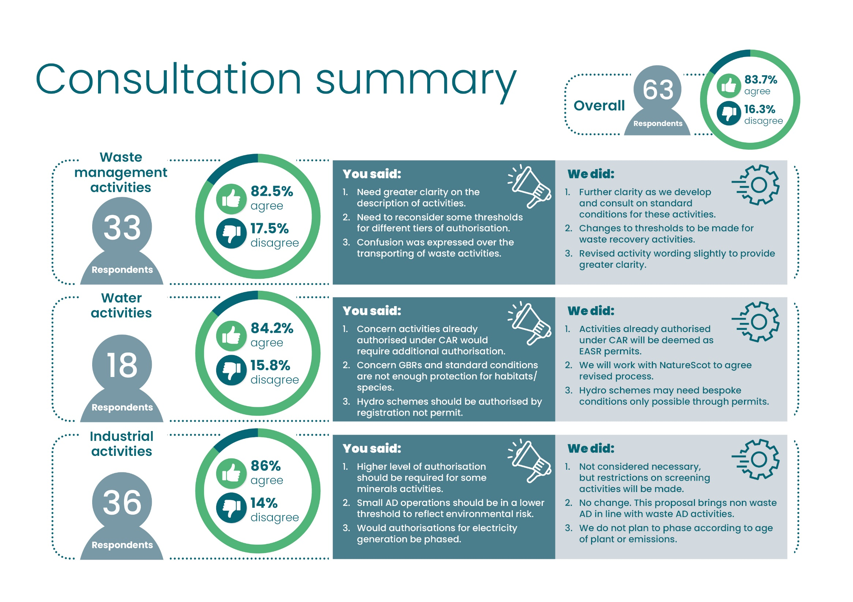

# Waste management activities

## Transporting waste

**We asked:** In sections [5.3](https://consultation.sepa.org.uk/regulatory-services/better-regulation-consultation-types-of-authorisat/supporting_documents/240208_Consultation_EASR2018_Types_of_authorisation.pdf) and [5.4](https://consultation.sepa.org.uk/regulatory-services/better-regulation-consultation-types-of-authorisat/supporting_documents/240208_Consultation_EASR2018_Types_of_authorisation.pdf) we sought agreement about the type and wording of authorisations proposed for transport of waste, about timescales for authorisations and about technical competence for acting as a broker or dealer for waste. We also sought views on other aspects of waste transport.

**You said:** There was strong agreement for our proposals. The main issues raised were in connection with timescales for authorisations and concerns that some businesses may require two separate authorisations to transport waste.

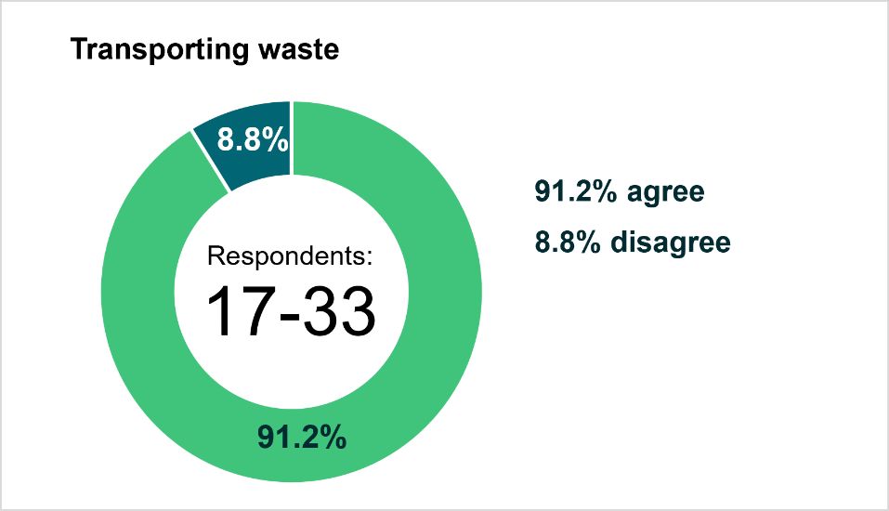

**We did:** We decided to amend the activity descriptions so that “Transporting waste produced by another person” authorisation will become “Transporting waste”, allowing holders of this authorisation to transport their own waste, as well as waste produced by others, without requiring an additional registration. We also decided to amend the authorisation period for transporting your own waste to three years to bring it in line with the registration that allows the transport of other people’s waste.

## Storage and treatment of waste

**We asked:** In section [5.5](https://consultation.sepa.org.uk/regulatory-services/better-regulation-consultation-types-of-authorisat/supporting_documents/240208_Consultation_EASR2018_Types_of_authorisation.pdf), we sought agreement about the type and wording of authorisations proposed each activity. We also sought views on other aspects of waste storage and treatment.

**You said:** There was strong agreement for our proposals. The main issues raised related to the need for greater clarity in the activity description, whether some activities were at the right authorisation level and some concerns regarding fees.

**We did:** We decided to give consideration to addition of another registration for small scale storage of waste at bulking stations prior to onwards transfer, as well as specific thought given to conditions relating to electric vehicles. We moved some activities from the notification tier to either the registration tier or low risk positions. We are considering in consultation with Scottish Government how to respond to regulation of certain wastes at a wastewater treatment plant. Greater clarity and further detail will be provided as we develop and consult on standard conditions for these activities. We will also be consulting on charging.

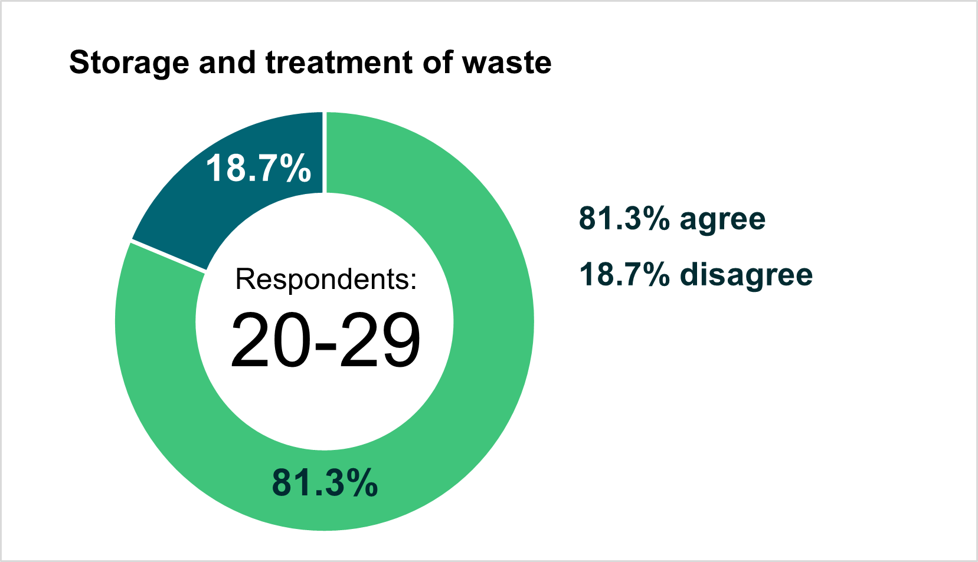

## Composting

**We asked:** In section [5.6](https://consultation.sepa.org.uk/regulatory-services/better-regulation-consultation-types-of-authorisat/supporting_documents/240208_Consultation_EASR2018_Types_of_authorisation.pdf), we sought agreement about the type and wording of authorisations proposed for different scales of composting.

**You said:** There was strong agreement for our proposals. The main issue raised related to the proposed thresholds for authorisations.

**We did:** We made no change to the proposed authorisations based on overall feedback, however greater clarity and further detail will be provided as we develop and consult on standard conditions for these activities.

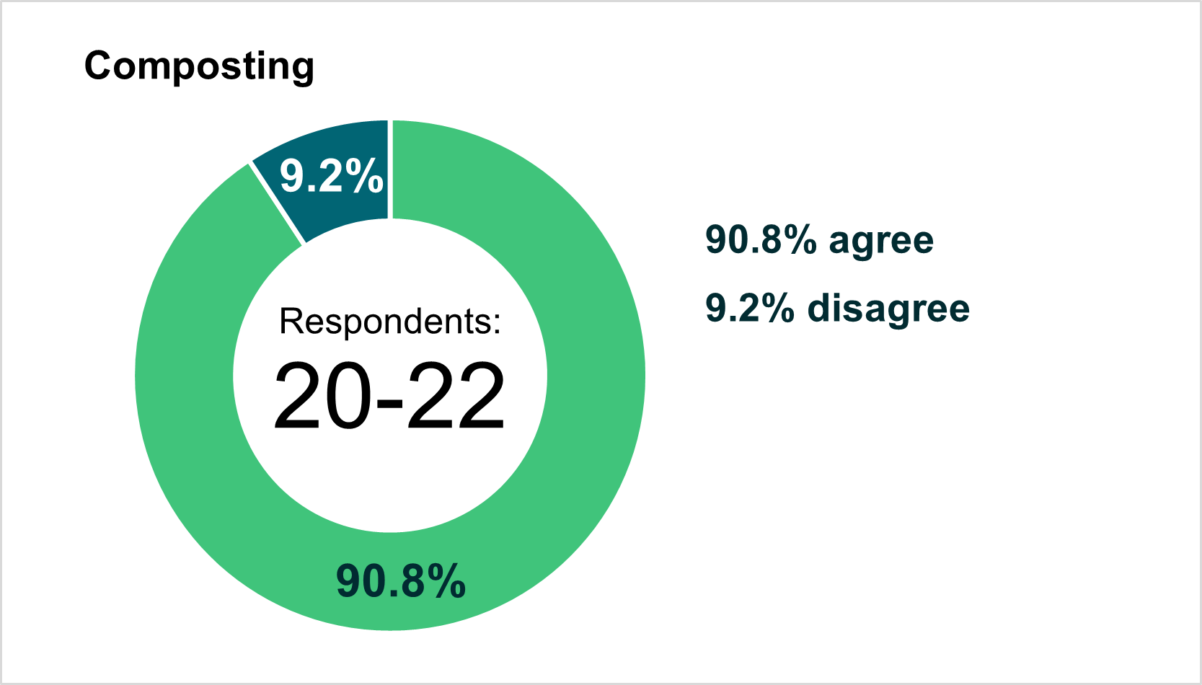

## Anaerobic digestion (AD)

**We asked:** In section [5.7](https://consultation.sepa.org.uk/regulatory-services/better-regulation-consultation-types-of-authorisat/supporting_documents/240208_Consultation_EASR2018_Types_of_authorisation.pdf), we sought agreement about the type and wording of authorisations proposed for different scales of AD.

**You said:** There was broad agreement for our proposals. The main issues raised related to providing more clarity and detail on definitions and on the proposed thresholds for authorisations, as well as how new proposals would align with or diverge from wider UK regulatory requirements.

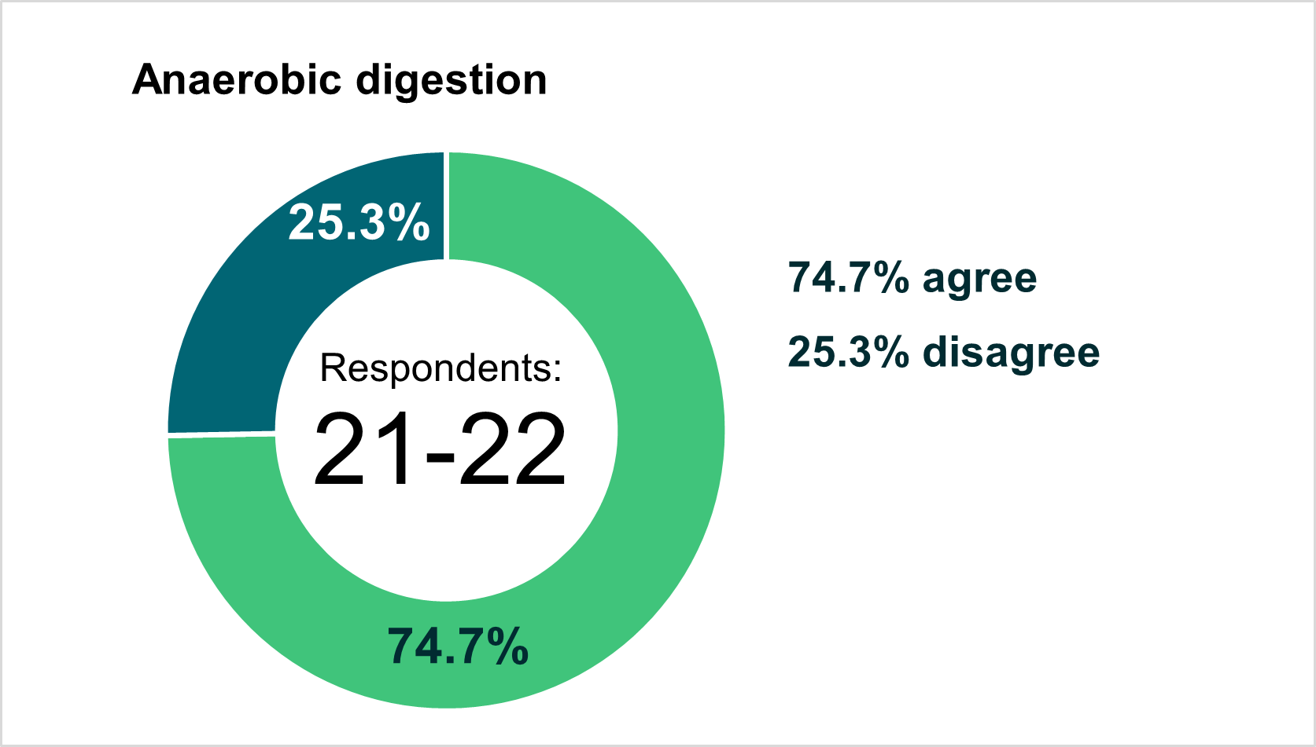

**We did:** We made no change to the proposed authorisations based on overall feedback. Greater clarity and further detail will be provided as we develop and consult on standard conditions for these activities.

## Recovery of waste

**We asked:** In sections [5.8](https://consultation.sepa.org.uk/regulatory-services/better-regulation-consultation-types-of-authorisat/supporting_documents/240208_Consultation_EASR2018_Types_of_authorisation.pdf) and [5.9](https://consultation.sepa.org.uk/regulatory-services/better-regulation-consultation-types-of-authorisat/supporting_documents/240208_Consultation_EASR2018_Types_of_authorisation.pdf), we sought agreement about the type and wording of authorisations relating to recovery of wastes through: application to land for soil improvement and for construction, restoration, reclamation or improvement of land.

**You said:** There was broad agreement for our proposals, albeit with a wide range of competing perspectives. The main issues raised related to providing more clarity and detail on definitions, more detail on what is covered by different authorisations and regarding the thresholds for authorisation types.

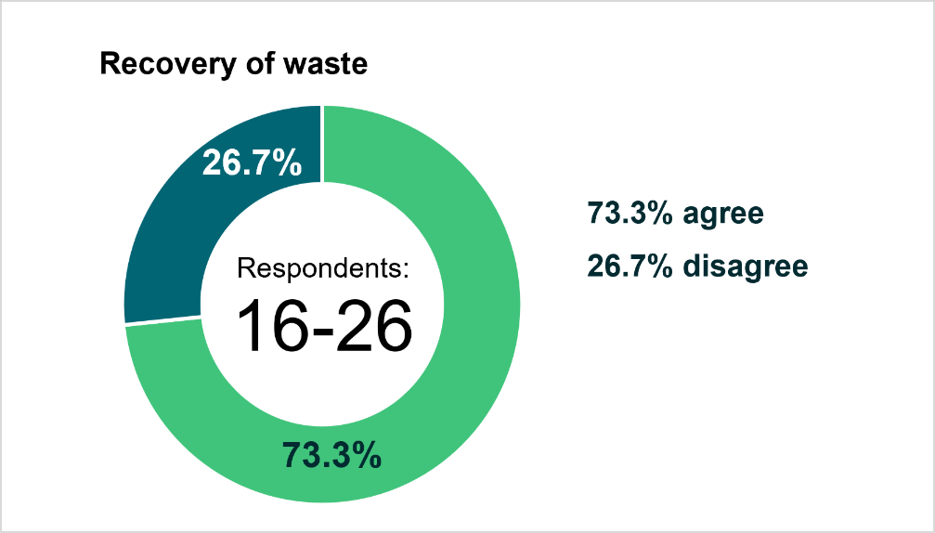

**We did:** We invited respondents to participate in a further stakeholder engagement session to better understand the concerns. Following this, we decided to adjust some of the tonnage limits and to adjust one of the registrations to remove the 100,000 tonne threshold from construction projects, retaining it for all restoration, reclamation and land improvement projects. Further detail will be provided as we develop and consult on standard conditions for these activities.

## Incineration and co-incineration

**We asked:** In section [5.10](https://consultation.sepa.org.uk/regulatory-services/better-regulation-consultation-types-of-authorisat/supporting_documents/240208_Consultation_EASR2018_Types_of_authorisation.pdf), we sought agreement about the type and wording of authorisations proposed for different scales of incineration and co-incineration.

**You said:** There was broad agreement for our proposals. No significant issues were raised except some views on the detail of what would be authorised.

**We did:** We are considering how best to regulate very small-scale biomass incineration. Further detail will be provided as we develop and consult on standard conditions for these activities.

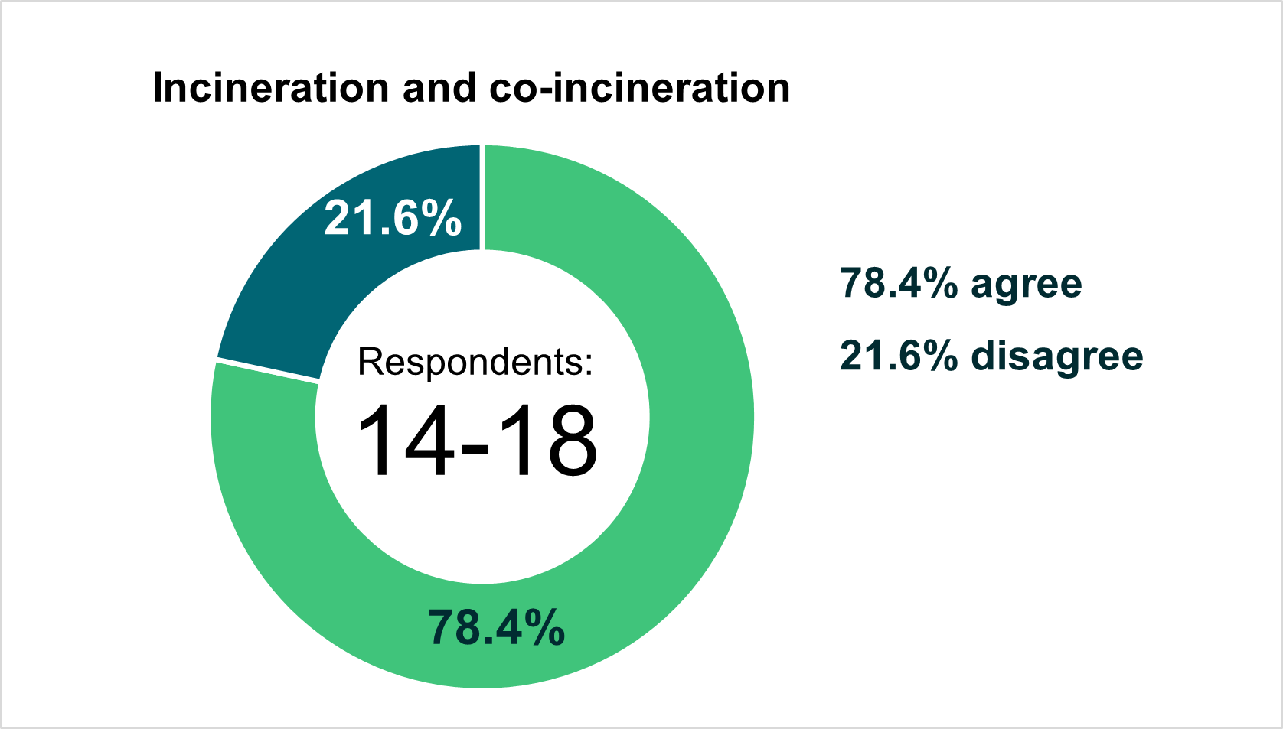

## Landfill

**We asked:** In section [5.11](https://consultation.sepa.org.uk/regulatory-services/better-regulation-consultation-types-of-authorisat/supporting_documents/240208_Consultation_EASR2018_Types_of_authorisation.pdf), we sought agreement about the type and wording of authorisations proposed for landfill of waste.

**You said:** There was strong agreement for our proposals. No significant issues were raised except some views on the detail of what would be authorised.

**We did:** We made no change to the proposed authorisations based on overall feedback. Further detail will be provided as we develop and consult on standard conditions for these activities.

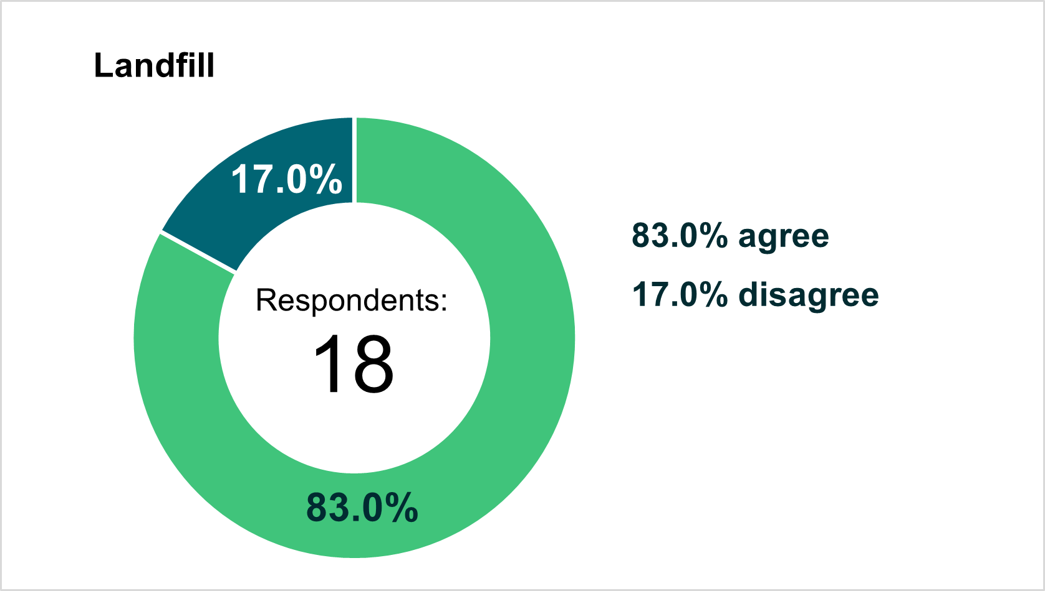

## Emerging waste activities

**We asked:** In section [5.12](https://consultation.sepa.org.uk/regulatory-services/better-regulation-consultation-types-of-authorisat/supporting_documents/240208_Consultation_EASR2018_Types_of_authorisation.pdf), we asked about awareness of new and emerging waste management activities that we should consider under the new framework.

**You said:** A number of activities were identified that may be appropriate for authorisation.

**We did:** We determined we would consider these activities and, if appropriate, further details about any we may consider for authorisation will be consulted upon, alongside draft standard conditions.

# Water environment activities

## Discharges and storage

**We asked:** In sections [7.2 to 7.13](https://consultation.sepa.org.uk/regulatory-services/better-regulation-consultation-types-of-authorisat/supporting_documents/240208_Consultation_EASR2018_Types_of_authorisation.pdf), we sought agreement about the type and wording of authorisations proposed for discharges into the water environment. This included authorisations covering discharges associated with sewage, finfish farms, swimming pools, surface water run-off, construction and quarries, sheep dip, disinfectants, and other effluents. This also included authorisations covering storage and use of materials that have the potential to pollute, including storage of pesticides and oil.

**You said:** There was strong agreement for our proposals. The main issues raised included: not authorising low risk sewage discharges by registration or notification (for example nature-based solutions), control of run off discharges into canals, concern about application of pesticides within 1m of a waterbody and if permit was the appropriate level of authorisation for the discharge of water run-off from a quarry or borrow pit constructed before 1 January 2022.

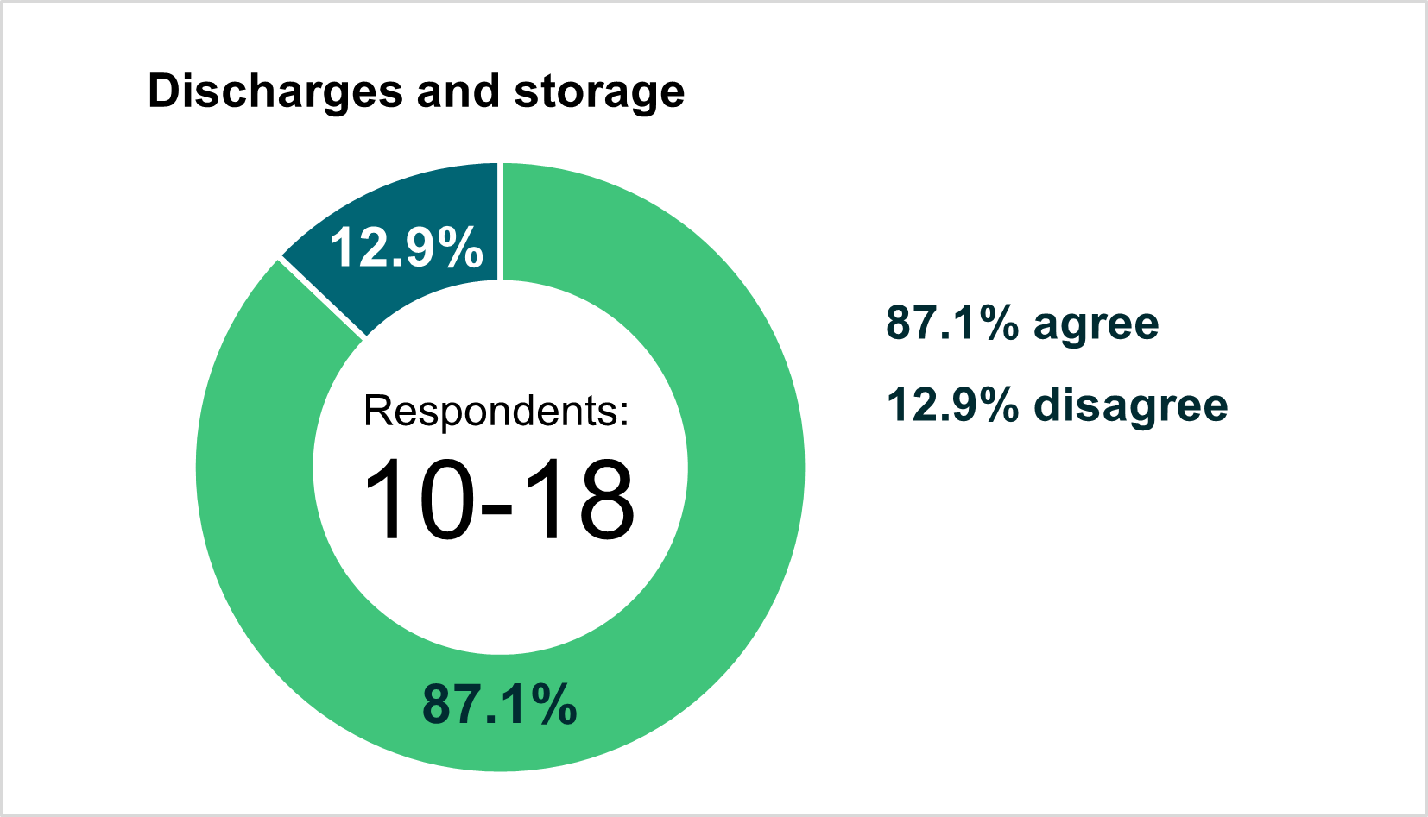

**We did:** We are proposing a small change to remove the permit activity of “discharges of water run-off from a quarry or borrow pit before January 2022”. Where discharges from quarries have or need authorisation, they can be captured under the permit level activity of "the discharge of effluents or disposal activities not otherwise described”. Greater clarity and further detail will be provided as we develop guidance for these activities.

## Abstraction activities

**We asked:** In section [8.2 and 8.3](https://consultation.sepa.org.uk/regulatory-services/better-regulation-consultation-types-of-authorisat/supporting_documents/240208_Consultation_EASR2018_Types_of_authorisation.pdf), we sought agreement about the type and wording of authorisations proposed for with water abstraction activities.

**You said:** There was strong agreement for our proposals. The main issues raised included whether additional authorisations would be needed where already authorised under CAR, that hydro scheme abstractions should be authorised by a registration and clarity on charging.

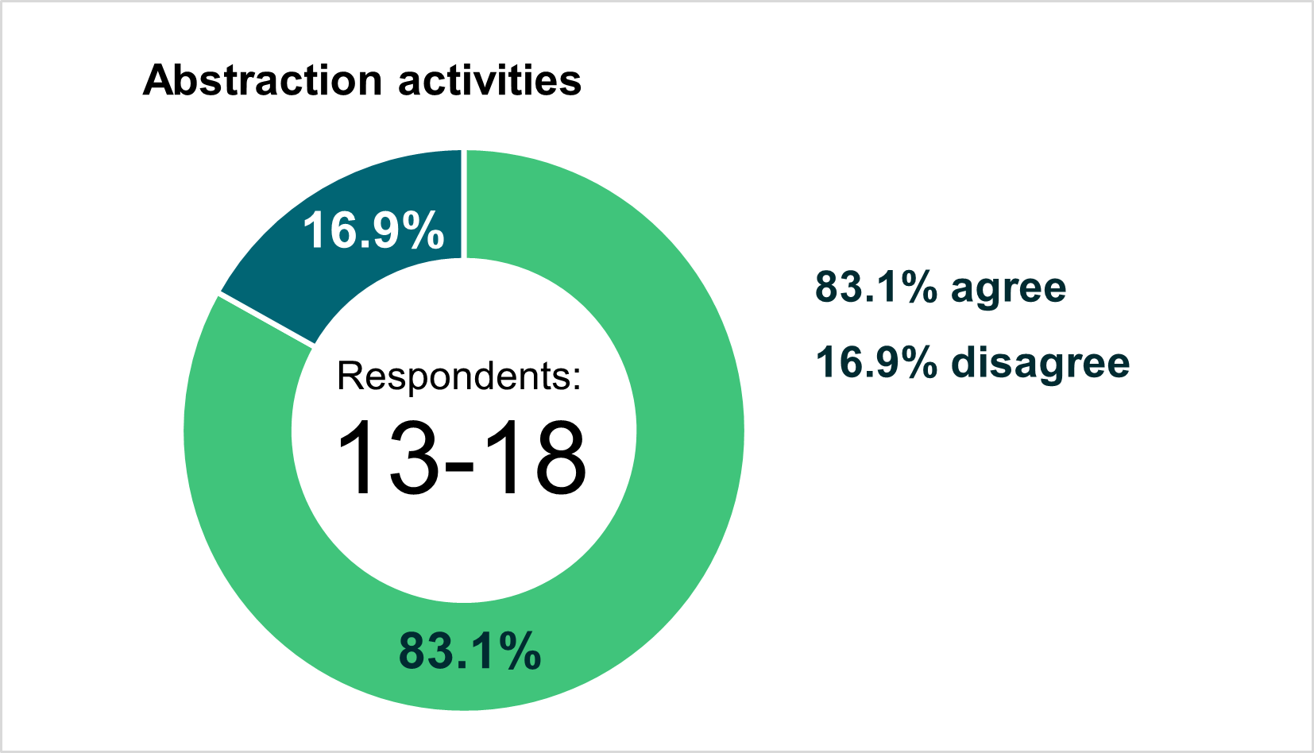

**We did:** No change to the proposed authorisations based on overall feedback which was overwhelmingly positive. Abstractions already authorised by a CAR licence will be deemed as EASR permits and no further application will be required. We will clarify this in guidance. We don’t agree that hydro scheme abstractions should be authorised by a registration as these schemes can impact on watercourses between the point of abstraction and discharge and may require bespoke conditions to be applied which can only be done via a permit. Further detail, including on charging will be provided as we consult on this in due course.

## Impoundment activities

**We asked:** In section [9.2](https://consultation.sepa.org.uk/regulatory-services/better-regulation-consultation-types-of-authorisat/supporting_documents/240208_Consultation_EASR2018_Types_of_authorisation.pdf), we sought agreement about the type and wording of authorisations proposed for activities associated with impoundment.

**You said:** There was strong agreement for our proposals. The main issues raised included impacts on fish and whether additional authorisations would be needed where already authorised under CAR.

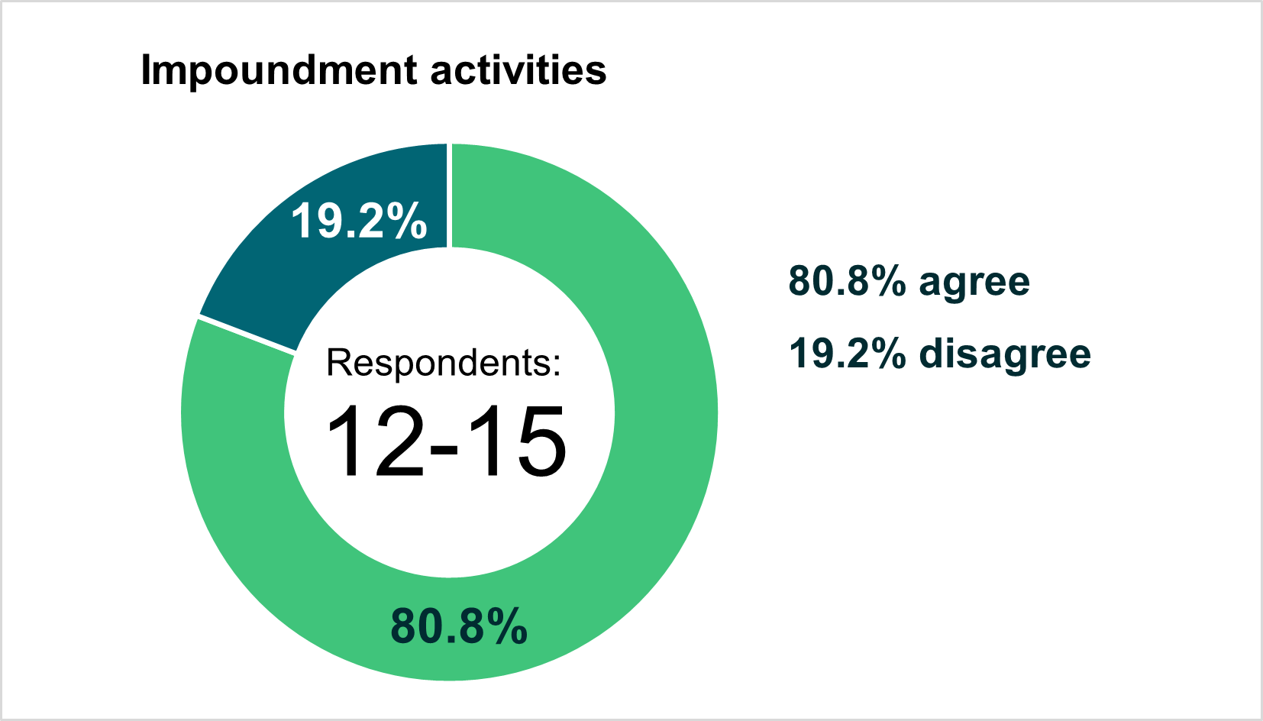

**We did:** We made no changes to the proposed authorisations based on overall feedback which was overwhelmingly positive. Greater clarity and further detail will be provided as we develop guidance for these activities.

## Engineering activities

**We asked:** In sections [10.2 to 10.11](https://consultation.sepa.org.uk/regulatory-services/better-regulation-consultation-types-of-authorisat/supporting_documents/240208_Consultation_EASR2018_Types_of_authorisation.pdf), we sought agreement about the type and wording of authorisations proposed for engineering activities affecting the water environment. This included bank works, channel modifications, crossings, in loch structures, sediment management, engineering activities in wetlands, maintenance, replacement and removal and other engineering activities.

**You said:** There was strong agreement for our proposals. The main issues raised included: clarification on whether authorisations would apply in specific circumstances, whether GBRs and standard conditions provide sufficient protection for protected species and clarity about authorisations in connection with artificial water bodies.

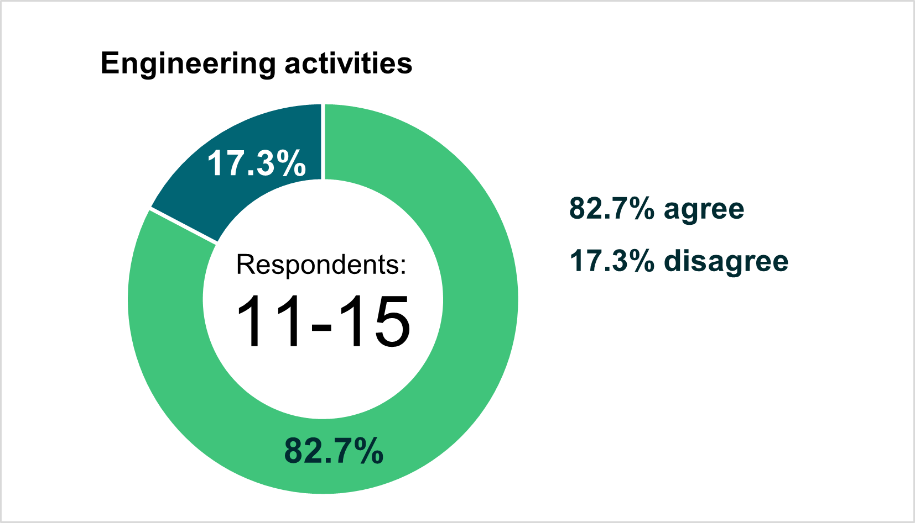

**We did:** No change to the proposed authorisations based on overall feedback which was overwhelmingly positive. We will work with NatureScot to agree a revised process to ensure the risks from structures to protected species and qualifying interests within protected areas are controlled. We will not be significantly changing our current approach to the regulation of engineering activities within artificial waterbodies or the authorisation of activities under emergency conditions. Our position on these will be set out when we revise and publish our guidance. Greater clarity and further detail will be provided as we develop and consult on standard conditions for these activities.

# Industrial activities

## Gasification, liquification and refining: petrol vapour recovery

**We asked:** In section [13.2](https://consultation.sepa.org.uk/regulatory-services/better-regulation-consultation-types-of-authorisat/supporting_documents/240208_Consultation_EASR2018_Types_of_authorisation.pdf), we sought agreement about the type and wording of authorisations proposed for these activities.

**You said:** There was strong agreement for our proposals. One respondent suggested a lower volume trigger for petrol vapour recovery.

**We did:** No change to the proposed authorisations based on overall feedback, which was overwhelmingly positive. A lower trigger for petrol vapour recovery would not be consistent with European standards.

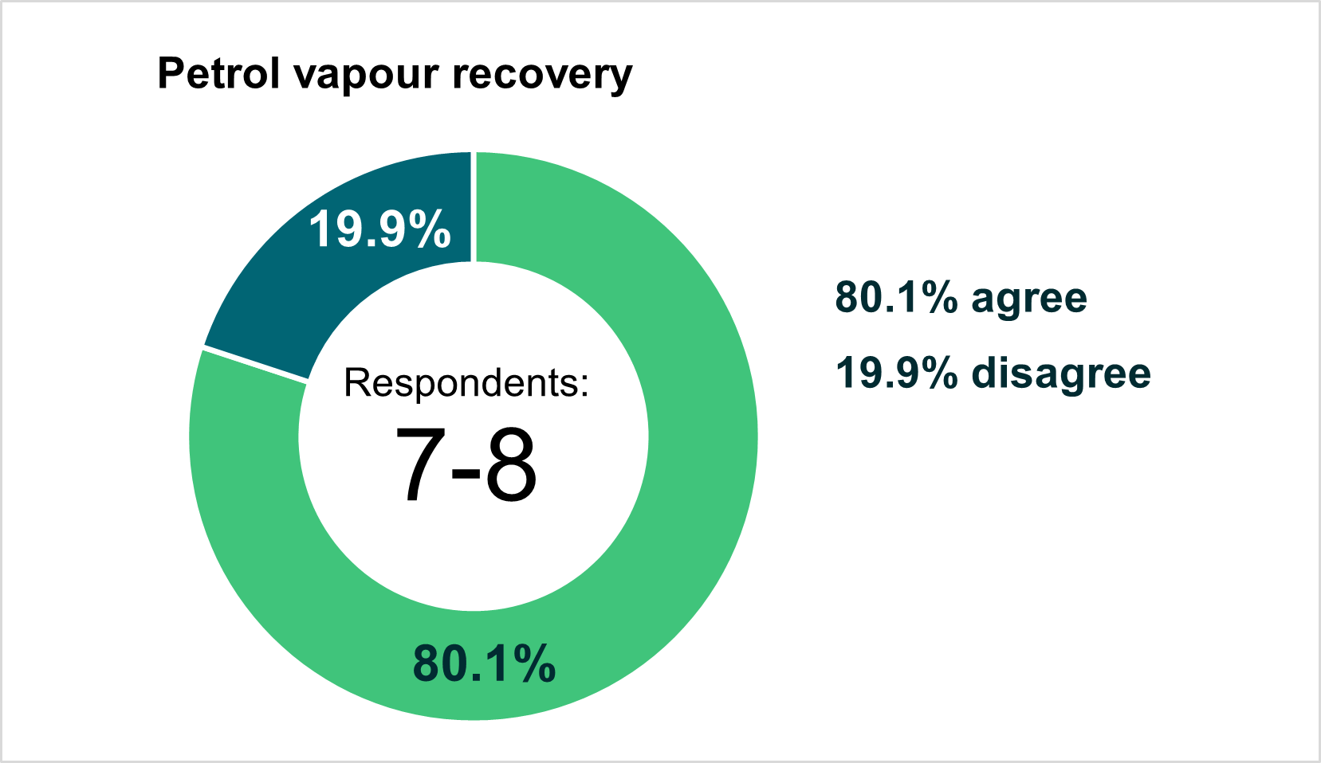

## Mineral activities

**We asked:** In section [13.3](https://consultation.sepa.org.uk/regulatory-services/better-regulation-consultation-types-of-authorisat/supporting_documents/240208_Consultation_EASR2018_Types_of_authorisation.pdf) and [13.4](https://consultation.sepa.org.uk/regulatory-services/better-regulation-consultation-types-of-authorisat/supporting_documents/240208_Consultation_EASR2018_Types_of_authorisation.pdf), we sought agreement about the type and wording of authorisations proposed for these activities.

**You said:** There was strong agreement for our proposals. The main issues raised were some views that a higher level of authorisation is required for some activities, including cement batching, crushing and screening, as well as some queries regarding the implementation of the GBRs.

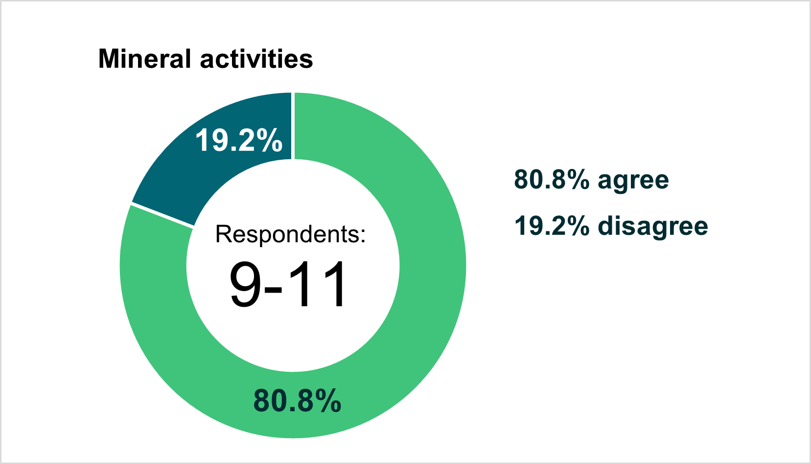

**We did:** Higher authorisation for the activities mentioned were not considered proportionate or necessary. However, we will put in place restrictions so that screening must take place at the place of production and to prevent the stockpiling of crushed materials. Greater clarity and further detail will be provided on the implementation of the GBRs in due course

## Coating activities, printing and textiles

**We asked:** In section [13.5](https://consultation.sepa.org.uk/regulatory-services/better-regulation-consultation-types-of-authorisat/supporting_documents/240208_Consultation_EASR2018_Types_of_authorisation.pdf), we sought agreement about the type and wording of authorisations proposed for these activities.

**You said:** There was strong agreement for our proposals. No significant issues were raised.

**We did:** No change to the proposed authorisations based on overall feedback which was overwhelmingly positive.

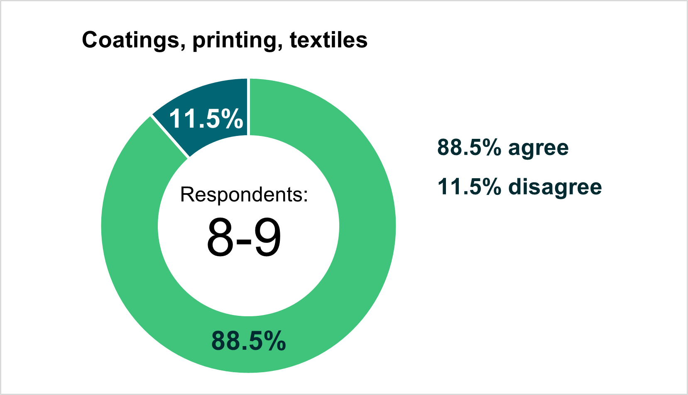

## Timber activities

**We asked:** In section [13.6](https://consultation.sepa.org.uk/regulatory-services/better-regulation-consultation-types-of-authorisat/supporting_documents/240208_Consultation_EASR2018_Types_of_authorisation.pdf), we sought agreement about the type and wording of authorisations proposed for these activities.

**You said:** There was strong agreement for our proposals. No significant issues were raised.

**We did:** No change to the proposed authorisations based on overall feedback which was overwhelmingly positive.

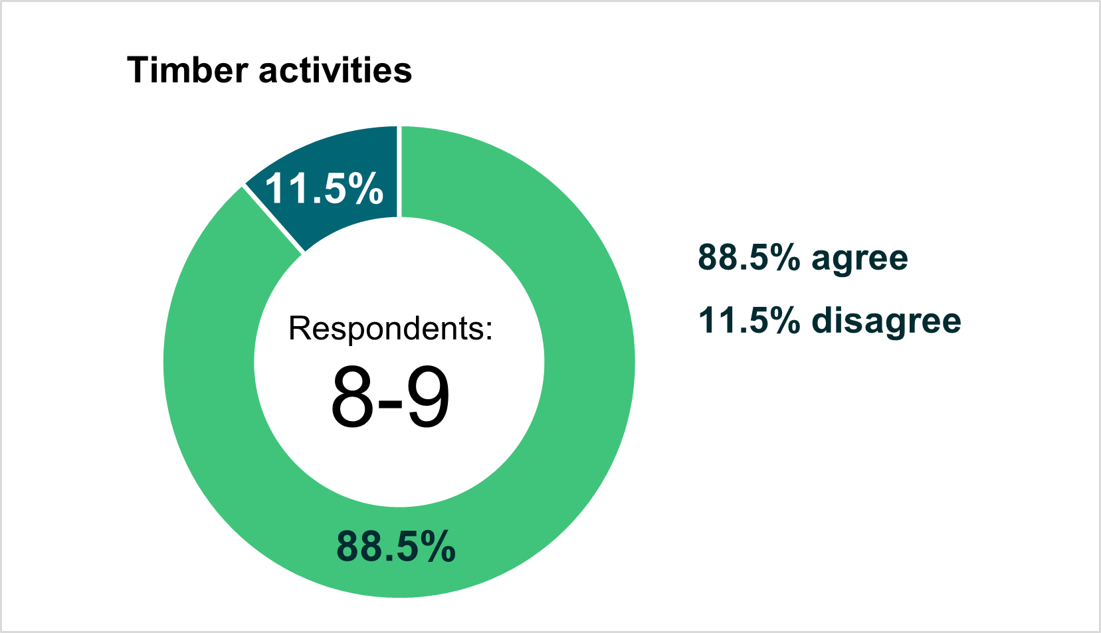

## Treatment of animal and vegetable matter and food industries

**We asked:** In section [13.7](https://consultation.sepa.org.uk/regulatory-services/better-regulation-consultation-types-of-authorisat/supporting_documents/240208_Consultation_EASR2018_Types_of_authorisation.pdf), we sought agreement about the type and wording of authorisations proposed for these activities.

**You said:** There was broad agreement for our proposals. The main issue raised was that the fish ensiling activity description was unclear.

**We did:** No change to the proposed authorisations based on overall feedback which was overwhelmingly positive. The wording regarding fish ensiling has been copied from PPC legislation however it is acknowledged that this is not clear and changes to the wording have been proposed to the Scottish Government. Greater clarity and further detail will be provided as we develop and consult on standard conditions for these activities.

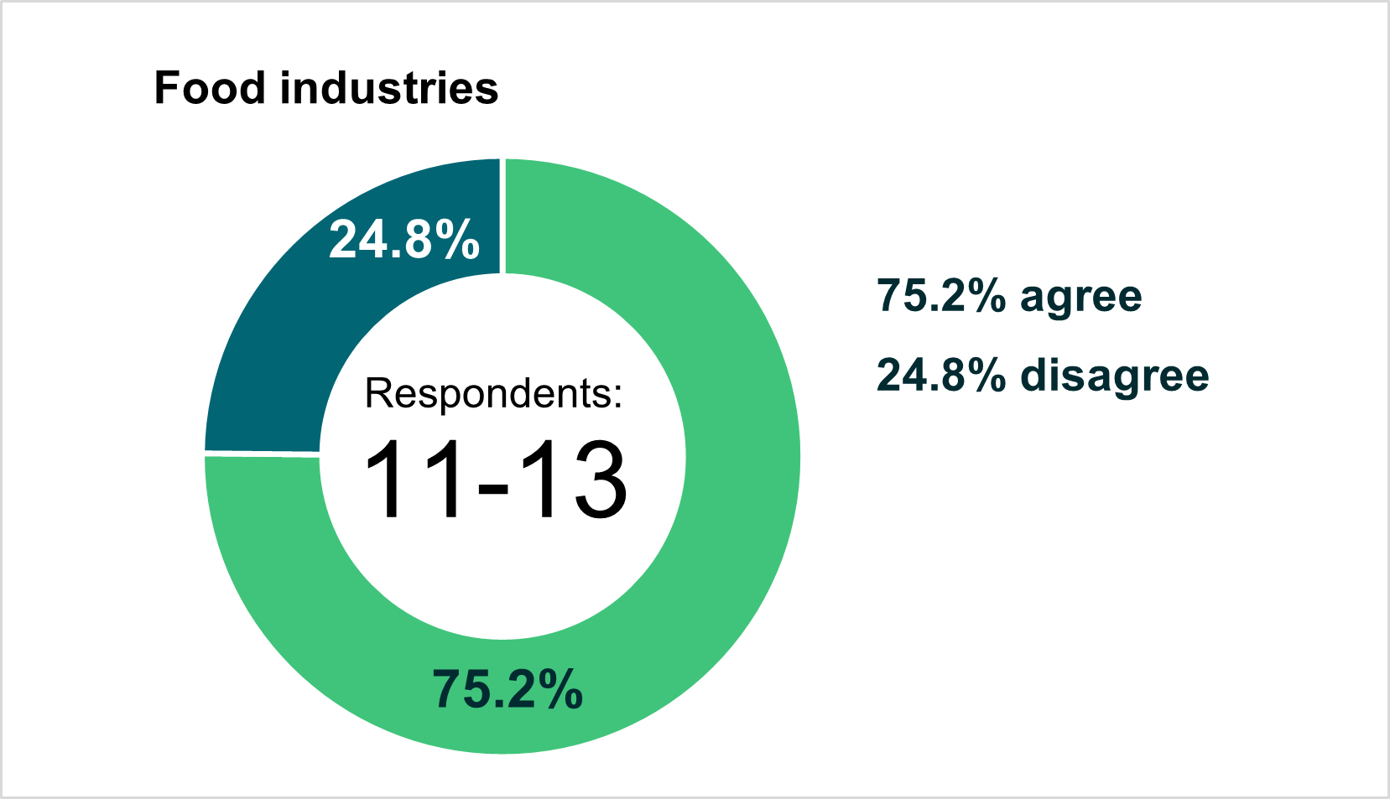

## Solvents Installations

**We asked:** In section [13.8](https://consultation.sepa.org.uk/regulatory-services/better-regulation-consultation-types-of-authorisat/supporting_documents/240208_Consultation_EASR2018_Types_of_authorisation.pdf), we sought agreement about the type and wording of authorisations proposed for operating a solvents installation.

**You said:** There was strong agreement for our proposals. No significant issues were raised.

**We did:** No change to the proposed authorisations based on overall feedback, which was overwhelmingly positive.

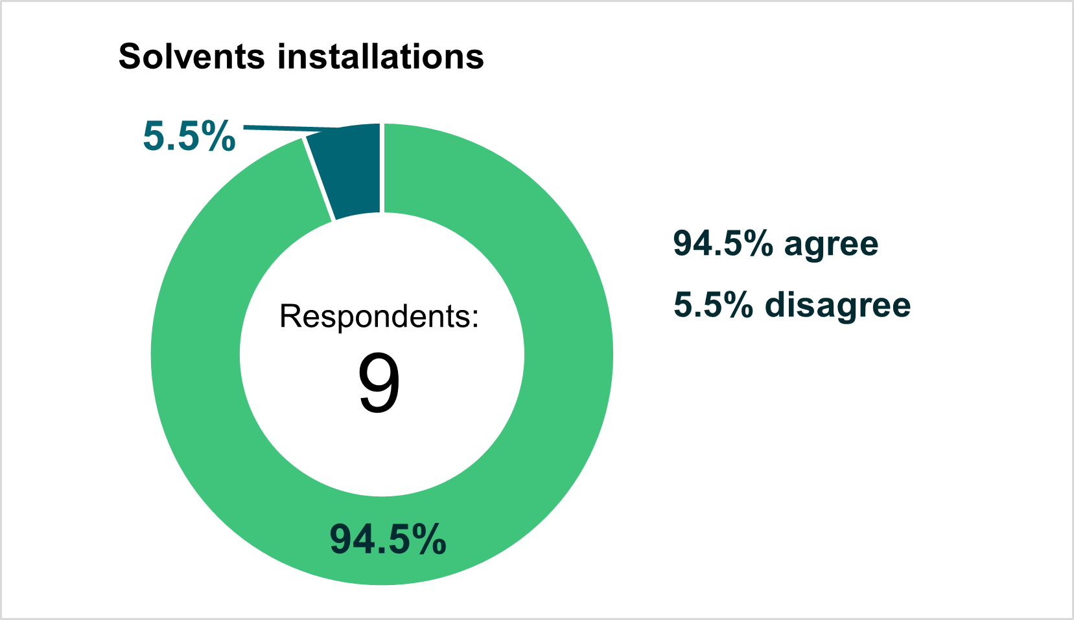

## Anaerobic digestion (AD) non-waste

**We asked:** In section [14.1](https://consultation.sepa.org.uk/regulatory-services/better-regulation-consultation-types-of-authorisat/supporting_documents/240208_Consultation_EASR2018_Types_of_authorisation.pdf), we sought agreement about the type and wording of authorisations proposed for activities associated with non-waste AD.

**You said:** There was strong agreement for our proposals. The main issues raised included: the impact of the threshold on smaller operations where it was felt it was disproportionate to the environmental risk; the need to recognise the role the generation of biogas serves to support decarbonisation of industry; concerns about retrospectively fitting secondary containment; and requests for further detail regarding the planned regulation of non-waste AD sites.

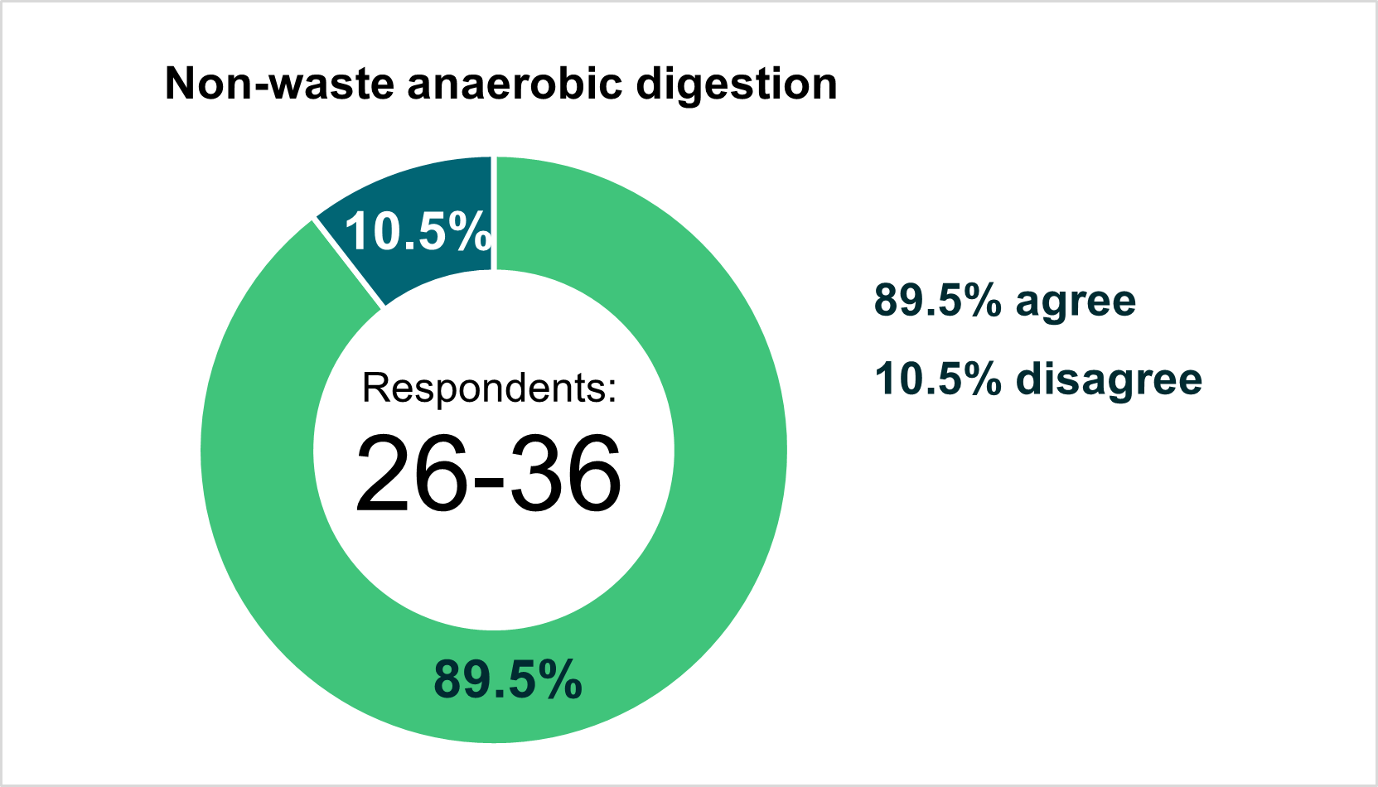

**We did:** No change to the proposed authorisations. The anaerobic digestion of non-waste materials has not to date been regulated in the same way as anaerobic digestion of waste, although the potential risks to the environment are similar. We have therefore aligned the threshold levels for both waste and non-waste anaerobic digestion activities. We acknowledge the contribution that lower carbon gases play in supporting transition to net-zero, but we need to also appropriately manage the significant associated environmental risks.

## Carbon capture

**We asked:** In section [14.2](https://consultation.sepa.org.uk/regulatory-services/better-regulation-consultation-types-of-authorisat/supporting_documents/240208_Consultation_EASR2018_Types_of_authorisation.pdf), we sought agreement about the type and wording of authorisations proposed for carbon capture.

**You said:** There was strong agreement for our proposals. The main issue raised was that regulation of carbon capture plants may reduce the scope for innovation and development of new technologies. It was requested that small scale and pilot carbon capture operations are exempt from the registration.

**We did:** No change to the proposed authorisations based on overall feedback, which was overwhelmingly positive. EASR, like PPC, will provide exemptions from regulation for research, development or the testing of new products and processes under certain circumstances. Greater clarity and further detail will be provided as we develop and consult on standard conditions for these activities and any associated guidance.

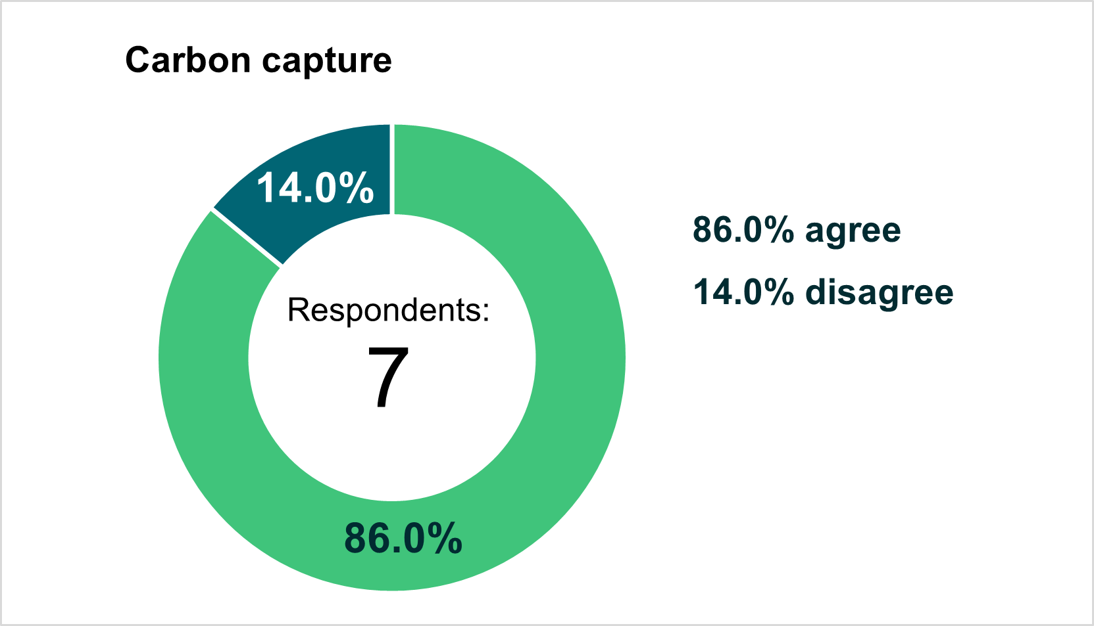

## Generators of electricity aggregating to 1MWth or more

**We asked:** In section [14.3](https://consultation.sepa.org.uk/regulatory-services/better-regulation-consultation-types-of-authorisat/supporting_documents/240208_Consultation_EASR2018_Types_of_authorisation.pdf), we sought agreement about the type and wording of authorisations proposed for activities associated with energy generation.

**You said:** There was strong agreement for our proposals. There was a query as to whether the requirement to hold an authorisation would be phased in according to age or generator emissions; one query regarding the impact on small businesses in rural location; and there were queries relating to what emission limit values and conditions will apply.

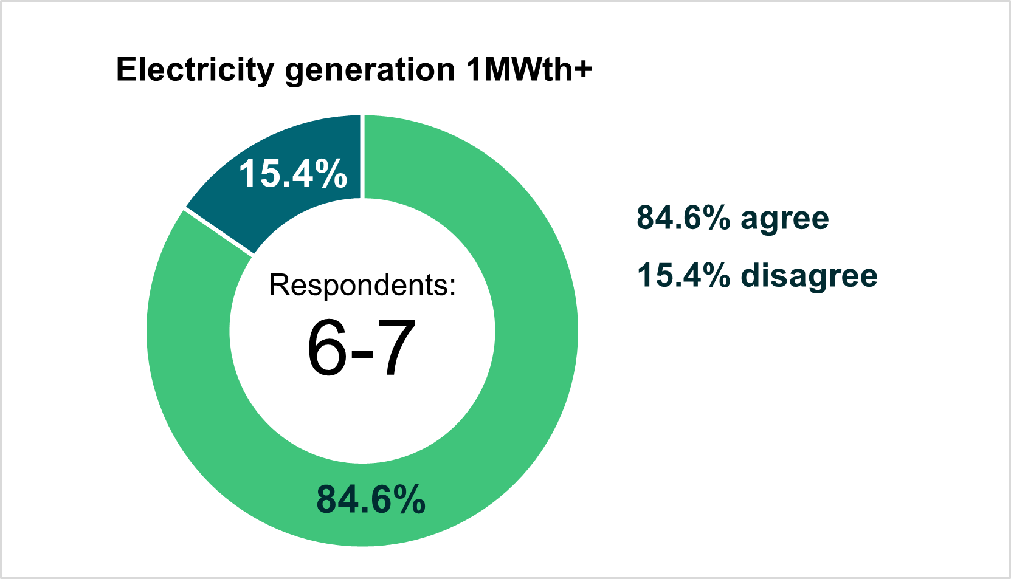

**We did:** No change to the proposed authorisations based on overall feedback which was overwhelmingly positive. We do not plan to phase according to age or emissions. Regarding the impact on small businesses in rural locations – businesses in this scenario will likely fall under the back-up plant exemption if they are providing power solely to the site in the event of power disruption. Greater clarity and further detail will be provided as we develop and consult on standard conditions for these activities and any associated guidance.