


Safeguarding Scotland’s Water Environment
December, 2025

Introduction
The water environment is one of Scotland’s most precious natural assets. It supports a rich diversity of wildlife; contributes to people’s health and well-being; and provides for the sustainable growth of Scotland’s economy. Protecting and improving this vital natural asset is fundamental to Scotland’s efforts to build resilience to climate change and to ensure that the needs of wildlife, people and the economy can be met and safeguarded into the future.
Our water environment exists within a complex landscape of urban development, agriculture, forestry, industry, and other natural habitats This complexity of uses, each with their own demands on the water environment, should be considered as a whole within a catchment-wide approach. This would provide a focus to share information and experiences of managing and appreciating our water environment.
River basin management planning (RBMP) is Scotland’s framework for protecting and improving the water environment and the benefits it provides. The RBMP sets out data on the state of the water environment in Scotland and information on the main pressures causing impacts.
Based on this, the RBMP then details a targeted and coordinated programme of action for Scottish Government, SEPA and other public bodies working with stakeholders to address those pressures and deliver the aims for protection and improvement.
Combining scientific evidence and data with local knowledge and the networks with capacity to deliver is necessary to deliver landscape scale restoration. Enabling integration of RBMP into decisions taken by land-managers, other businesses, public bodies and third sector will help promote the RBMP objectives to restore nature and deliver resilient catchments.

Scotland’s third river basin management plan (RBMP3) was published in December 2021 with an ambitious plan of action up to December 2027. During that time, we have made significant progress delivering actions to reduce rural diffuse pollution, remove and ease barriers to fish migration, restore urban rivers, mitigate impacts from hydropower generation and other water use and invest in improved treatment for public wastewater. Our understanding of the condition of the water environment and the pressures it faces has also continued to improve. This consultation is the first step in the review and update of the RBMP and will be followed by a consultation on a draft RBMP4 in December 2026, with a reviewed and updated plan due to be published by December 2027.

Significant Water Management Issues
Scotland’s water environment is experiencing unprecedented and accelerating pressure from climate change with increased temperatures, droughts and flooding. The water environment is also under continued and evolving threats from pollution, loss of habitat and invasive species. All of this means that the benefits provided to nature, people and the economy are at risk. In turn, Scotland’s ambitions for nature recovery and climate adaptation, which are dependent on a functioning and resilient water environment, are also at risk.
To safeguard and grow the benefits Scotland’s water environment provides requires effective management of the issues that are having a negative impact on those benefits. These problems are the significant water management issues for RBMP. They are defined as issues that are having a significant adverse impact on the condition of the water environment, and where we have a clear understanding of the actions required, although there may be gaps in the policies and mechanisms required to deliver those actions.
The following sections describe the significant water management issues we have identified for RBMP4. The condition of the water environment is a good barometer for the health and sustainability of land-use, both in towns and cities and the countryside. It is also a good indicator of how well Scotland is achieving a circular economy, reusing materials and eliminating waste. As such, many of the issues set out below cut across policy areas and will require public bodies, land managers and other stakeholders to find new ways of working within catchments and urban areas to address them systemically and we welcome your suggestions on how best to do this as part of this consultation.

Rural Diffuse Pollution
Scotland is widely recognised as having one of the leading approaches in Europe for dealing with rural diffuse pollution. By working directly with around 12,000 farms in 57 priority catchments, we have made significant progress promoting the benefits of sustainable agriculture and ensuring compliance with the general binding rules for diffuse pollution. Compliance rates increased from 36% at initial farm visits during RBMP1 to 63% in RBMP3, with 90% of non-compliant farms taking action to improve compliance within 12 months. This has seen improvements in the management and application of fertilisers, reduced risks from pesticides, improved land cultivation, reduced the impact of livestock on watercourses and improved the management of slurry and run-off from farm steadings.
SEPA’s ongoing work with Scotland’s farming community to reduce the risk from rural diffuse pollution has contributed to improvements in bathing water classifications over the past decade, which alongside other measures, has seen the number of designated bathing waters classified as Excellent rise from 17 in 2015, to 47 in 2025.
The work with the farming community has been particularly apparent in regions such as Ayrshire, where improvements required by SEPA have included increased slurry storage, fencing, alternative sources of livestock watering, and the planting of riparian “buffer zones” to move farming activities back from watercourses.
However, we are yet to see widespread reductions in nutrient concentrations in the water environment. Elevated nutrient levels cause significant harm to wildlife and increase the costs of treating drinking water. More action is needed to tackle this problem, which could include measures such as;
- Better soil management – reducing compaction, preventing erosion, minimising bare soil including the increased use of cover crops, reduced tillage where appropriate and increasing soil organic matter.
- Nutrient budgeting including making best use of organic fertilisers– matching inputs (including from waste applied to land) to nutrient levels in soils and requirements of crops.
- Enhanced buffer strips and other in-field measures (including intercepting tile drainage) to disrupt the pathways that transport nutrients to the water environment.
- A better understanding of the impact of wastewater on nutrient levels and other contaminants, in particular the contribution of private wastewater.
As well as protecting the water environment, these actions can also contribute to reducing costs to farmers, protecting yields in the long-term, improving wider biodiversity and reducing greenhouse gasses and ammonia emissions. Soil management also has the potential to help mitigate water scarcity and flood risk, by storing water and reducing run-off.
SEPA will work with the Scottish Government and other stakeholders to consider the measures required and how they can support the government’s aim for Scotland to be a world leader in sustainable and regenerative agriculture.

Physical Condition of Rivers
The complexity of features found in natural rivers and their riparian woodlands and wetlands are vital for biodiversity, providing important habitat and habitat connectivity for wildlife, increasing resilience to high flows, higher temperatures and droughts. Healthy and functioning rivers also clean water through the uptake of nutrients and breaking down of organic matter. By storing and slowing down water, in combination with other natural features in catchments, rivers can also reduce flood risk and mitigate impacts of water scarcity. In urban areas, blue-green infrastructure around healthy rivers provides opportunities for public amenity and active travel, supporting the health and wellbeing of local communities.
However, many of these benefits have been lost over recent times as Scotland’s rivers have been modified to create space for agriculture, urban development, improve drainage and store water for hydropower generation and public water supply. Sixty-one % of Scotland’s rivers have been sufficiently modified to downgrade their classification from natural or near natural (High status), with 25% less than good status. Climate change is also increasing the energy and volumes of sediment in river systems as the frequency and magnitude of heavy rainfall and high flows increase. Combined with a history of modifications, this is putting at risk key infrastructure in and around our rivers.
The Scottish Government has provided funding to SEPA through the Water Environment Fund to work with partners to restore rivers with a focus on providing community benefits. During RBMP3, 6 projects have been delivered in communities across Scotland. Twenty-one more projects are in development, with 6 due to be complete before December 2027. Based on scoping work carried out to date, there is the opportunity for a further 10 to 15 additional urban river restoration projects as part of RBMP4, delivering significant benefits for local communities, including increasing resilience to climate change as a key component of building blue-green infrastructure in our towns and cities.
In rural areas, there are opportunities to work with farmers and land-managers to provide space to allow rivers to recover naturally. Current Good Agricultural and Environmental Conditions (GAECs) creating buffer strips and protecting banks from erosion, and General Binding Rules (GBRs) to tackle rural diffuse pollution could be amended to increase buffers around rivers. Grants for further increasing buffer strips, reconnecting rivers with their floodplains, planting riparian woodlands and improving riparian wetlands could also contribute. Private investment in carbon credits and the developing market in biodiversity has potential to pay farmers for providing rural rivers with more space. The right combination of measures could create the conditions where the farming sector routinely provides more space for rural rivers, delivering significant benefits for biodiversity, helping to manage flood risks and the impacts of water scarcity, while improving water quality and minimising the impact on productivity. SEPA can provide expertise, data and opportunity maps to support this work.

Artificial Barriers to Fish Migration
As part of the physical modifications to rivers described above, the water environment in Scotland contains many structures built for water storage, navigation, water abstraction, and crossings for road and rail transport. A significant number of these cause barriers to the migration of wild fish, preventing access to important spawning and rearing habitat. These fish, including Atlantic salmon, sea trout, European eels, lamprey, are facing a range of pressures at sea and in freshwater, not least from climate change. Atlantic salmon in particular are an iconic symbol of biodiversity in Scotland and support an important part of Scotland’s rural economy. Eighty-two percent of Scotland’s salmon stocks are in poor or moderate conservation status in 2025 and the total number of salmon returning to coastal waters continues to be in decline since estimates began in the 1970s.
Removing or easing barriers to migration and increasing the amount of freshwater habitat available is a key action in the Scottish Wild Salmon Strategy. It’s a relatively straightforward and effective measure that can be taken to increase the resilience of wild fish populations to climate change. The removal of barriers also promotes natural river processes, habitats and connectivity benefiting a range of species.
Working with a range of partners, through the Water Environment Fund and regulation, we have made good progress on removing and easing fish barriers during RBMP3. Twenty-five have been removed or eased to date, opening up over 1,300 km of river, with another 138 projects at various stages of licencing, design and build. We are also finding more structures potentially requiring action as we scope and investigate work, bringing the total number left to be addressed to around 175. These projects often require significant investment and take several years to design and implement. In addition, there are numerous structures which are partially passable and where the cumulative impact on wild fish populations is not yet fully understood.
To protect and recover wild fish populations, and to support the parts of the rural economy that depend on them, will require continued work and investment. SEPA will work with fishery boards and trusts, Scottish Government and other stakeholders to continue the programme of barrier removal and easement during RBMP4.

Sea Lice from Marine Fish Farms
One of the other significant issues for wild fish populations is the assessment and management of the interaction between sea lice from marine fish farms and wild Atlantic salmon and sea trout. In sufficient concentrations, sea lice can have a significant adverse impact on these migratory species. We currently assess and manage the risk posed by sea lice to wild salmon and sea trout when determining applications for proposed new marine fish farms or to increase the permitted maximum biomass of fish held at existing fish farms.
We now need to focus on gathering additional information necessary to understand the effects of sea lice from existing marine fish farms on wild salmon and sea trout. We expect this will involve several years of data gathering. Where the evidence collected shows significant adverse impacts on wild salmon or sea trout, we will ensure appropriate and targeted action is taken to reduce pressure from sea lice as part of the RBMP programme of measures and so help improve the condition of wild salmon or sea trout.

Water Use
Eighty-nine percent of Scotland’s rivers, lochs and groundwaters are in good condition for water resources. However, these water resources are still under threat from climate change with more frequent and severe water scarcity periods being experienced. Five out of last 8 years have seen significant water scarcity in Scotland and climate change will see water scarcity increasing in frequency and severity in coming years. Growing demands for public water supply, agriculture, renewable energy generation and other business uses are also increasing the pressure on our water resources. To continue to meet these demands into the future, we need to ensure our water resources are resilient to a changing climate and managed within environmental limits.
To address this Scotland needs proactive management of water resources. This will require understanding the impact of climate change on long-term water availability, an assessment of future demands against supply risks, improved monitoring and metering of abstractions to understand use and drive efficiency, and a framework for prioritising and allocating water based on efficient use and the needs of wildlife, people and businesses.
Catchment management to store and slow down water will also have an important role to play, including investment in natural assets, for example through peatland restoration, better soil management and river restoration.
SEPA will work with the Scottish Government, water users and other stakeholders to take forward the proactive management of water resources under RBMP to mitigate the impacts of climate change and water scarcity on nature, people and the economy.

Wastewater and Sewer Networks
There has been considerable investment in Scotland over recent decades to improve wastewater discharges. During RBMP3, Scottish Water is delivering further investments to improve water quality at 34 wastewater treatment works and 21 unsatisfactory combined sewer overflows (CSOs), leading to additional benefits for Scotland’s water environment. This work has been focussed on addressing the main impacts from public wastewater on bathing waters and the good condition target for Scotland’s water environment.
Wastewater treatment works and sewer networks can also have a localised impact on water quality, amenity and wildlife. These localised impacts are often associated with wider issues of surface water management in urban areas during heavy rainfall, linked to a changing climate and demographic shifts. As part of the solution to these issues, SEPA required Scottish Water to produce an Improving Urban Waters Routemap which set out a programme of action and investment to improve the performance of sewer networks and reduce spillages. SEPA will work with Scottish Water to ensure a revised and updated improving urban waters routemap is ambitious and shows a clear pathway to dealing with issues associated with sewer networks.
Across Europe, a recast Urban Wastewater Treatment Directive (UWWTD) has introduced a requirement for integrated urban wastewater management plans for larger populations, prioritising green-blue infrastructure wherever possible to reduce impacts from sewer networks. The recast UWWTD also introduces stricter treatment standards for nutrients (amongst other things) and new obligations for monitoring chemicals, microplastics and antimicrobial resistance. It also extends the requirement for wastewater treatment to smaller communities and introduces extended producer responsibility.
SEPA will work with Scottish Government, Scottish Water and other stakeholders to consider the requirements of a recast UWWTD in Scotland.

Chemicals in the Water Environment
Globally there are over 350,000 registered chemicals and chemical mixtures, representing an exponential increase over recent decades. Chemicals have many uses and societal and economic benefits, but they can also be released into the environment during their lifecycle and be potentially harmful to people and wildlife. There is increasing public concern over a wide range of chemical issues including pesticides, pharmaceuticals, veterinary medicines, chemicals that are long-lived in the environment (e.g. forever chemicals), and chemical mixtures.
The number of chemicals in use and potentially emitted into the water environment poses a challenge in terms of understanding risks. This is particularly difficult when considering mixtures of chemicals and interactions with other environmental conditions such as climate and land-use change. This complex picture requires a change in approach to the way in which we monitor and assess the presence of this wide range of chemicals and the risks they may pose to Scotland’s water environment.
Innovations in laboratory analytical capabilities mean that it is now possible to identify a large number of chemicals in more cost-effective ways. This is a shift away from more traditional monitoring approaches which focused on a small number of chemicals. When fully implemented, this new approach will enable a marked change to our environmental monitoring programmes and a shift to our evidence base and how we characterise the water environment. As well as approaches to understanding the presence of chemicals in the environment, SEPA is continuing to work with stakeholders, partner organisations and the research community to improve our understanding of the risks due to chemicals and other contaminants of increasing concern, such as microplastics, nanomaterials and antimicrobial resistance.
The chemicals regulatory landscape in the UK and the EU is complex, with some chemical substances regulated by use type (e.g. The Plant Protection Products Regulations or the Human Medicines Regulations) and others regulated by broader regulations such as UK REACH. Chemicals regulations aim to control and restrict the use of chemicals considered to be of most concern. Many of the traditional controls available to SEPA are at the point of discharge e.g. by requiring treatment of sewage or engineering of a landfill. However, such measures can be technically challenging, expensive and carbon intensive. There are often alternative interventions that could be put in place by working with partners, other stakeholders and regulatory bodies. It is often better for action to be taken at source, especially for substances associated with widespread risk.
SEPA will continue to work with the Scottish Government and partners who have a lead role in delivering chemicals regulations including UK Government and other regulators (environment agencies, Health and Safety Executive etc). We will also work with other key stakeholders, including the NHS, large global chemical and pharmaceutical companies, and the research community to develop the partnerships and approaches needed to understand and manage the risks posed.
This review of the river basin management plan provides the opportunity for us to reconsider our approach to maintaining a healthy water environment and look for innovative and collaborative solutions to the SWMIs and the cross-cutting themes described in the next section.

Finding New Ways of Working
The water environment is a good barometer for the sustainability of land use in Scotland and our progress towards achieving a circular economy that reuses materials and minimises waste. As such, the significant water management issues (SWMIs) are indicative of wider systemic problems Scotland faces with the management of the environment. Scotland’s public bodies, businesses and other stakeholders will need to find new ways of working together to tackle these issues and put in place the actions needed that will safeguard the water environment now and into the future. This will require coordination across different policy areas, public bodies and sectors. It will also require an understanding of the interdependencies between the water environment and the management of other natural assets within catchments, such as soils, peatlands, floodplains and woodland, leading to a better understanding of Scotland’s natural capital to help inform investment decisions by the public and private sector.
We are proposing to use the themes of climate adaptation, nature and health and wellbeing to present and organise information in the RBMP to support coordination of action across sectors and within catchments. In doing so, people from a range of sectors and policy areas will be able to access and use the information relevant to them to inform decisions and take action. In each section, we have included a Treemap showing the pressure data from RBMP3 mapped to the themes of climate adaptation, nature and health and wellbeing. The size of the rectangles in the Treemaps show the relative number of water bodies affected by each pressure where the delivery of benefits for that theme may be negatively impacted.

Climate Adaptation
The water environment is on the front line of climate change, experiencing higher temperatures and more frequent and damaging floods and periods of water scarcity. Five out of the last 8 years has seen significant water scarcity in Scotland. Approximately 284,000 properties in Scotland are at risk of flooding, expected to rise to 394,000 due to the impacts of climate change (based on the 2018 National Flood Risk Assessment). The severity of impacts from floods and water scarcity are indicative of catchments where the use of land and water is not resilient to climate change and out of balance with the needs of people and wildlife.
The Scottish National Adaptation Plan 3 (SNAP3) includes the water environment as a crucial component of Scotland’s climate resilience strategy. To support the aims of SNAP3, we will make information on the evidence and action under RBMP relevant to climate adaptation available through a climate adaptation theme. Closer coordination and integration with flood risk management and longer-term water resource planning will also be a priority for SEPA during RBMP4.
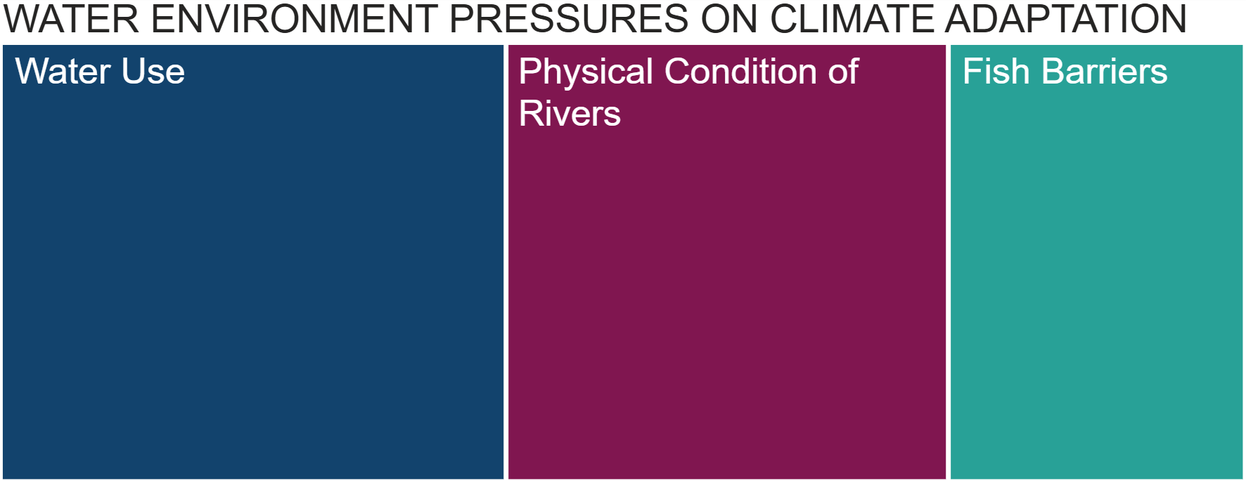
Figure 1: Relative proportions of the number of water bodies impacted by the pressures relevant to the Climate Adaptation theme based on RBMP3 data.

Nature
The water environment is fundamental for the protection and recovery of nature in Scotland. The Scottish Biodiversity Strategy to 2045, describes Scotland having restored and regenerated biodiversity across land, freshwater and seas. The outcomes for rivers, lochs and wetlands in 2045 includes restored river catchments and waterbodies in good condition. The vision for the Scottish Wild Salmon Strategy is that wild Atlantic salmon populations are flourishing and an example of nature’s recovery. A key objective is Scotland’s rivers having healthy, self-sustaining populations of wild Atlantic salmon by improving the condition of rivers and giving salmon free access to cold, clean water. The delivery plans for both strategies link their objectives to the delivery of actions in the RBMP. To support coordination and delivery, we will make information on the evidence, aims and actions under RBMP relevant to the Scottish Biodiversity Strategy and Wild Salmon Strategy available under a Nature theme. SEPA will work to ensure RBMP4 is a key delivery mechanism to realise Scotland’s ambitions for nature recovery and the protection of wild salmon.
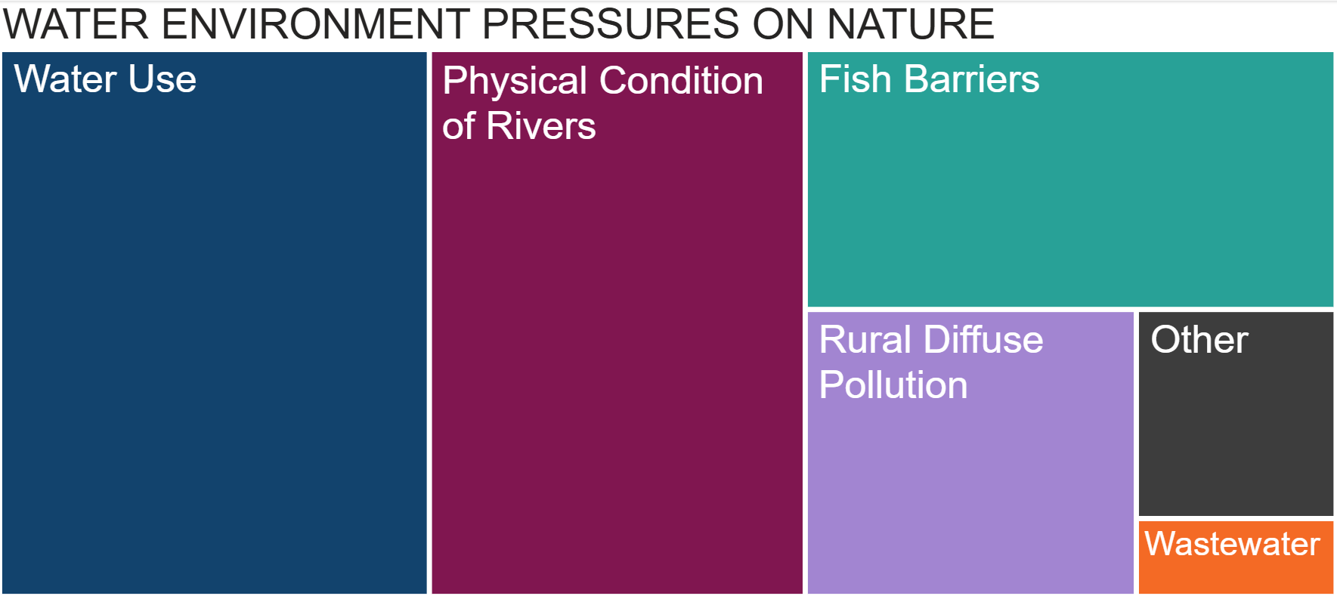
Figure 2: Relative proportions of the number of water bodies impacted by the pressures relevant to the Nature theme based on RBMP3 data.

Health and Wellbeing
The water environment plays a key role in supporting the health and wellbeing of people in Scotland. It provides a source of clean water for public drinking water supplies, food production, opportunities for recreation, including access to safe bathing waters, provides amenity and links to active travel. The health and well-being benefits of bringing people into contact with a good quality natural environment are well understood and the water environment is integral to this. The public rightly has high expectations when it comes to the quality of Scotland’s water environment and their access and enjoyment of it.
To support coordination with efforts to manage health and wellbeing in Scotland, we will make relevant information on the evidence, aims and actions under RBMP available under a health and wellbeing theme. The Treemap below does not include chemicals or other contaminants of increasing concern. Analytical capabilities and the understanding of risks and impacts of these is still developing and the intention is to include them in in future iterations of the RBMP as appropriate.
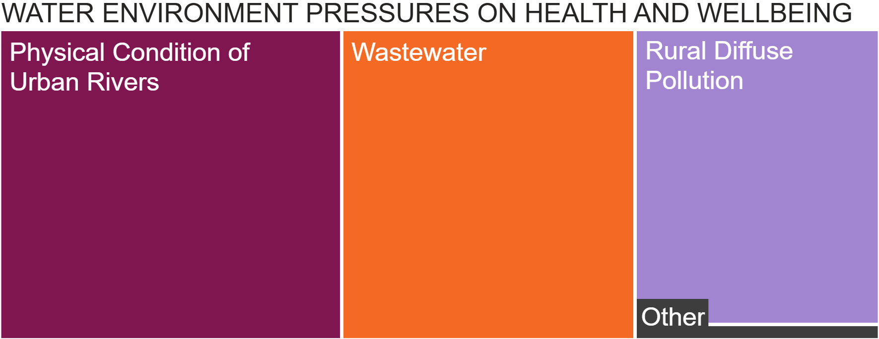
Figure 3: Relative proportions of the number of water bodies impacted by the pressures relevant to the Health and Wellbeing theme based on RBMP3 data.

Summary
Scotland’s water environment is a precious natural asset that supports biodiversity, health and wellbeing, and the economy. Through RBMP, significant progress has been made improving compliance with diffuse pollution regulations, restoring urban rivers, removing and easing barriers to fish migration, ensuring more sustainable water use and enhancing wastewater treatment. These efforts have contributed to increasing resilience to climate change, protecting and restoring nature and improving the health and well-being of people in Scotland.
Looking ahead to RBMP4, we have the opportunity to review and revise how we work together to ensure we have a healthy water environment. We welcome feedback on ways of collaborating that we can develop further in the draft RBMP due to be published by December 2026.

Continued action and focus on the significant water management issues will be required to safeguard the benefits Scotland derives from the water environment. Climate change and emerging risks from chemicals and other contaminants are intensifying the pressures on Scotland’s water environment. By organising RBMP4 around the themes of Climate Adaptation, Nature, and Health and Wellbeing, SEPA aims to foster cross-sector collaboration and systemic solutions that safeguards Scotland’s water environment for future generations. We look forward to hearing your views.

If you would like this document in an accessible format, such as large print, audio recording or braille, please contact SEPA by emailing equalities@sepa.org.uk

Scottish Biodiversity Strategy to 2045
Scottish National Adaptation Plan 2024 – 2029
The status of salmon in Scotland: 2025
The Scottish Wild Salmon Strategy
Wang et. al. (2020). Toward a Global Understanding of Chemical Pollution: A First Comprehensive Analysis of National and Regional Chemical Inventories. Environmental Science and Technology, Vol. 54(5).
https://informatics.sepa.org.uk/NFRA2018/
NatureScot - Benefits of Green Health

